STUDENT SATISFACTION ON THE LEARNING MATERIALS RELATED TO TUTORIAL, EXAM AND GRADE

Maximus Gorky Sembiring¹, Nurdin Ibrahim², Gayuh Rahayu³

¹Universitas Terbuka (INDONESIA)
²Universitas Negeri Jakarta (INDONESIA)
³Institut Pertanian Bogor (INDONESIA)

The 32nd Annual Conference of the Asian Association of Open Universities 2018
“Open Education in Human Resource Development in Asia’s Period of Integration”
Hanoi, Vietnam, 24-26 October 2018

Sub-topic 2:
Open Education in Technical, Vocational and Skills Development

Abstract

Determinants of learning materials satisfaction related to tutorial involvement, exam readiness and grade achievement in Universitas Terbuka perspective was investigated. It was aimed at validating on how, in what behavior factors involved were interrelated. The study was completed under the mixed method: exploratory design. It was qualitatively established first that learning materials satisfaction was signified by 8I (8 independent variables: writer, accuracy, significance, structure, readability, interactivity, utility and presentation). Satisfaction (M, moderating variable) led to 3D (3 dependent variables: tutorial, exam and grade). These configurations were completed under review and focus-group discussion activities first as a part of qualitative approach. Survey was conducted afterward to gather data from students newly graduated for quantitative purpose. Methodically, it was hypothesized that M was influenced by 8I; M had positive effect on the 3D. Eleven hypotheses were developed and assessed utilizing structural-equation model (SEM), including observing their power of relations. Moreover, important-performance analysis (IPA) and customer-satisfaction index (CSI) were utilized to concurrently measure satisfaction level and its importance degree. It was statistically inferred that seven out of 11 hypotheses were validated by the analysis. It was suggested that presentation of learning material was the most influential factor to satisfaction followed by writer, accuracy and significance. Additionally, tutorial was influenced by satisfaction followed by grade and exam. The IPA-CSI analysis indicated that the top three attributes as the pillar of learning material were writer competency, equitable presentation and goal accuracy. Unpredictably, structure, readability, interactivity and utility were excluded as some predictors to satisfaction.

Keywords: Satisfaction, exploratory design, IPA, CSI, SEM

- INTRODUCTION

The study was initially prepared and presented for International Conference on Open and Innovative Education 2018 hosted by Open University of Hong Kong on July this year (Sembiring, 2018). It was initiated by first reflecting to these fundamental questions: What makes open distance learning (ODL) courses effective related to student satisfaction? What aspects of courses perceived from instructional design upshot impacting academic achievement and/or representing barriers to success? Are there specific features contributing to learning effects with respect to tutorial engagement, exam readiness and grade accomplishment? Those three key reflections were essential related to the attrition rates that still relatively remain high in ODL atmosphere as compared to the traditional learning processes (Kauffman, 2015). In addition, most students perceived ODL materials in a different way than that of face to face. Negative views, especially an imprecise one, might direct to disparaging learning endings with possible decreased motivation and persistence. They could lead to negative emotions including frustration in case they are inadequately constructed and/or students do not exhibit required skills to learn at a distance (Berenson, Boyles & Weaver 2008). Learning at a distance mode might not be appropriate for everyone. Identifying student characteristics contributing to student success versus failure might help to foresee conceivable learning corollaries. This is to prevent them from enrolling courses supposedly the nature of the atmosphere was not fit for them. By recognizing these qualities, it reinforced the management to construct quality learning materials to meet student needs.

Universitas Terbuka is a single mode and the only ODL institution operated by now in Indonesia. The University offered 40 undergraduate and graduate level under four faculties. The University provided more than thousand courses in printed and digitized format (Universitas Terbuka, 2018) with almost 300,000 students managed through 40 regional offices to serve students throughout Indonesia and overseas (Universitas Terbuka, 2017). Current data showed that around half of students were not able to achieve grade point average (GPA) in the rage of 3.00-4.00. There were some factors might cause these effects; internal and external factors. Internally, it might be caused by academic and/or administrative factors. Externally, it might be caused by situational, dispositional and epistemological (including technological) constraints viewed from student stance (Sembiring, 2015; 2016; 2017). Three main academic factors included learning materials, tutorial support and evaluation. The other three administrative factors included registration, logistic distribution and examination. For this study, student performance and satisfaction were intentionally perceived limited to the learning material factors.

The study was then aimed at searching for factors related to satisfaction on learning materials of Universitas Terbuka perceived by students newly graduated related to their tutorial engagement, exam readiness and grade achievement. It was also of interest to validate how and in what routines factors engaged were interconnected one another. Technically, it was expressed by asking the following two questions: What are the portraits of existing learning materials perceived by users? How to use that portrait might be useful to rearrange better materials? Answer from the first question is to figure out the position of learning materials used up to this stage. The answer from the second question is to improve satisfaction level of learning materials to assure students satisfaction and success.

It was subsequently expected that by this endeavor there will be an enhancement not only in pedagogy aspect but also access to knowledge, social interaction and the presence of lecturer in ODL context. By preserving this perception, it is presumed that most adult working distance learners fear of failure might be anticipated and carefully controlled viewed from academic outlook.

- CONCEPTUAL FRAMEWORK

This study is conceptually rationalized by the initial framework as exhibited in Figure 1.

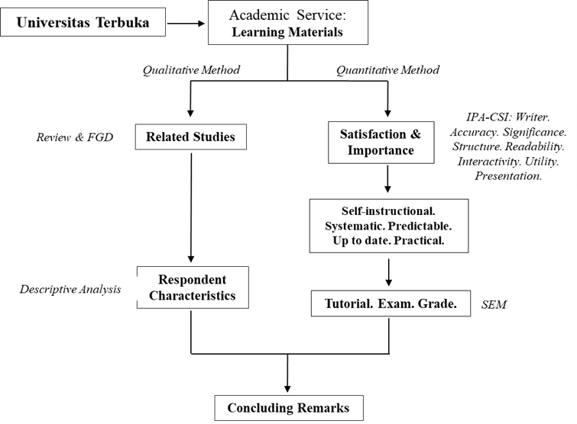

Figure 1. The Conceptual Framework

This is completed by the sets of literature reviews and focus-group discussions (FGDs) series under qualitative approach as a consequence of using exploratory design (qualitative first and then followed by quantitative series). Learning materials as part of academic services are derived from the University Strategic Plan as elaborated in Quality Assurance Guides. Quantitatively, learning materials dimensions are evaluated under customer-satisfaction index (CSI) and important-performance analysis (IPA) approach first and then followed by structural-equation model (SEM) technique to examine the hypotheses and the loading factors of the operational framework. Under qualitative approach, it can conceptually be recapitulated the variables and dimensions engaged as shown in Table 1.

Table 1. Variables and Dimensions Engaged

No | Variables | Dimensions | Remarks
1 | Writer  I₁ | I₁₁: Competence  I₁₂: Experienced  I₁₃: Well-known | I₁₋₈, M and D₁₋₃ were independent, moderating and dependent variables successively  Each independent variable (I) has 3 dimensions with 3 questions for each dimension  These questions should be answered 2 times concurrently by the respondents  The first part of each question measured the satisfaction level and the second part measured its importance degree  M was influenced  by I₁₋₈  Other variables (D₁₋₃) were influenced by satisfaction (M)  Questions on these variables (D₁₋₃) answered only one time  Total questions:  (2x29) + (9+1) = 68
2 | Accuracy  I₂ | I₂₁: Rationale  I₂₂: Goals  I₂₃: Activities
3 | Significance  I₃ | I₃₁: Strategic  I₃₂: Contributive  I₃₃: Innovative
4 | Structure  I₄ | I₄₁: Well-organized  I₄₂: Flexible  I₄₃: Simple
5 | Readability  I₅ | I₅₁: Hierarchical  I₅₂: learning domain  I₅₃: perceptible
6 | Interactivity  I₆ | I₆₁: Learner-focused  I₆₂: Engaging  I₆₃: Error-tolerance
7 | Utility  I₇ | I₇₁: Purposeful  I₇₂: Relevance  I₇₃: Applied
8 | Presentation  I₈ | I₈₁: Integrated  I₈₂: Equitable  I₈₃: Well-paced
9 | Learning Material Satisfaction  M | M₁: Self-instructional  M₂: Systematic  M₃: Predictable  M₄: Up to date  M₅: Practical
10 | Tutorial  D₁ | D₁₁: Face to face  D₁₂: Media  D₁₃: On demand
11 | Exam  D₂ | D₂₁: Assignment  D₂₂: Paper-based  D₂₃: Online
12 | Grade  D₃ | D₃₁: Raw score  D₃₂: Good grade  D₃₃: Good GPA

They were resulted from related literature reviews and series of FGDs by involving selected faculty and eligible students from the University. At this stage, 12 variables were identified and they were divided into three categories. The first is eight independent variables consisted of writer, accuracy, significance, structure, readability, interactivity, utility and presentation. The second is a moderating variable namely learning material satisfaction. The third is three dependent variables consisted of tutorial engagement, exam readiness and grade achievement factors (Bates, 2015; Moore and Kearsly, 2012; Smaldino et al., 2008; Sembiring, 2015 and 2017).

- DESIGN AND METHODOLOGY

Learning materials satisfaction is the moderating variable (M). It will quantitatively be observed by eight independent variables (8I). They are: writer, accuracy, significance, structure, readability, interactivity, utility and presentation. These eight factors are observed with respect to aspects on self-instructional, systematic, predictable, up to date and the practical of learning materials provided, used and experienced by users. Each independent variable is observed by three attributes. Independent variables with three attributes of each dimension are used to observe the satisfaction level and their importance degree. It will be observed whether or not satisfaction has effect on tutorial engagement, exam readiness and grade attainment; these are the dependent variables (3D). The operational framework will be developed and assessed elaborated from summary exhibited in Table 1.

The study utilized exploratory design, part of mixed methods (Creswell and Clark, 2011). This implies the study was implemented under qualitative approach first then followed by quantitative sequence. Two types of instruments were developed: list of queries for literature review and FGD (qualitative) and questionnaire (quantitative) series. Table 1 is a basis of developing instruments.

The qualitative approach was used to form basic elements of the conceptual framework by conducting FGDs. This was done by involving selected four academic from the University and four active students resided in four different regional centers. Experts and students, as resource persons, were mainly asked four questions and categorized as: (1) What are the main variables of learning materials related to satisfaction (M), (2) What are the dimensions attached to each variable engaged, (3) What would be the impact of satisfaction to student satisfaction and (4) What their view on existing learning material provided by the University.

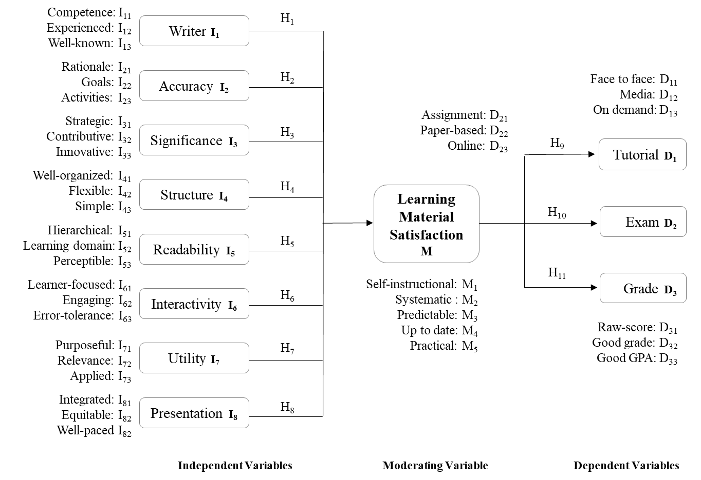

Figure 2. The Operational Framework

Variables and dimensions engaged are explored through questionnaire (Bird, 2009). Survey was implemented to gather information by following Fowler (2014). Population is 1,200 newly graduated students from all faculties. Purposive sampling for qualitative and simple random sampling techniques for quantitative purposes were determined to selecting eligible respondents (Cochran, 1977). Six hundred questionnaires were distributed and 241 were finally completed. IPA and CSI were then simultaneously used to assess satisfaction level along with their importance degree (Wong et al., 2011). SEM was used to discover conceivable interactions amongst factors engaged (Hair et al., 2009). The operational framework was then established by reflecting summary in Table 1 becomes Figure 2.

Figure 2 illustrated features affecting learning materials satisfaction (M) led to tutorial (D1), exam (D₂) and grade (D₃). Satisfaction (M) includes features such as self-instructional (M₁), systematic (M₂), predictable (M₃), up to date (M₄) and practical (M₅). Satisfaction is signified by perceiving dimensions of writer (I₁), accuracy (I₂), significance (I₃), structure (I₄), readability (I₅), interactivity (I₆), utility (I₇) and presentation (I₈) configurations. The instrument consists of 2x29 questions related to the satisfaction degree and the level of its importance. Another nine and one questions are to validate whether or not dependent variables (D₁₁-D₃₃) were relatable to satisfaction; 68 questions in total. Serially, these results will be unified with the results obtained from qualitative approach. The result will be confronted with student views to see whether they are the same, different or conflicting one another.

Statistically, this study tests 11 hypotheses (H₁₋₁₁, Figure 2). Learning material satisfaction (M) is directly influenced by writer (H₁), accuracy (H₂), significance (H₃), structure (H₄), readability (H₅), interactivity (H₆), utility (H₇) and presentation (H₈) as independent variables. In addition, tutorial (H₉), exam (H₁₀) and grade (H₁₁), as dependent variables, are directly influenced by satisfaction (M).

- RESULTS AND DISCUSSIONS

Having exhibited related fundamentals conceptually and operationally, we are now in the position of exposing the results of hypotheses and later the loading factors of the operational framework; including the goodness of fit of the tested framework by considering all related facts as previously shown in Figure 2. The statistical processes, using R, inferred that seven out of 11 hypotheses tested are positively validated by the analysis. They are writer (H₁=I₁), accuracy (H₂=I₂), significance (H₃=I₃), presentation (H₈=I₈), tutorial (H₉=D₁), exam (H₁₀=D₂) and grade (H₁₁=D₃); for α=0.10. This implies that structure (H₄=I₄), readability (H₅=I₅), interactivity (H₆=I₆) and utility (H₇=I₇) were not validated by the analysis.

To have a more comprehensive view on the end result, it would be better to reveal the characteristics of respondents (Table 2). This will give us better perception to comprehend the discussion before exposing the final outcomes.

Table 2. Respondents Characteristics

Faculty | Education=52 | Economics=18 | Science=3 | Social=21 | Graduate=6
GPA | 2.00-2.45=11 | 2.50-2.99=58 | 3.00-3.49=18 | 3.50-3.99=12 | 4.00=1
Age (year) | ≤ 24=12 | 25-34=43 | 35-44=28 | 45-54=14 | ≥ 55=3
Study Length | ≤ 5 year=42 | 6 year=38 | 7 year=14 | 8 year=4 | ≥ 9 year=2
Profession | Public=45 | Private=32 | Self-own =3 | Part Time=16 | None=4
Gender | Female=72 | Male=28 | Marital | Yes=72 | No=28

Note: All numbers are in %
Table 2 in general revealed that respondents are students newly graduated and representing eastern-western part of Indonesia. They were also representation of all faculties; most of them are adult workers. The respondents are dominated by females and graduated from Faculty of Education with educators as their profession. Most importantly, the vast majority of them were smart energetic and married.

Having extracted the hypotheses analysis and respondent characteristics, here is the findings from IPA-CSI Chart before elucidating the loading factor analysis. The analysis was intended to expose satisfaction level and importance degree at once. The analysis generated spots of the satisfaction level in conjunction with related quadrants (Q) to comprehend their importance degree (Figure 3).

Figure 3 (Wong et al., 2011), has four quadrants: Q₁ (Low Satisfaction, High Importance: Concentrate Here), Q₂ (High Satisfaction, High Importance: Maintain Performance), Q₃ (Low Satisfaction, Low Importance: Low Priority) and Q₄ (High Satisfaction, Low Importance: Possible Overkill).

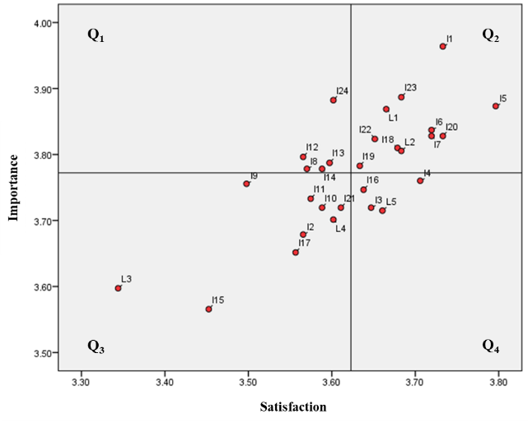

Figure 3. IPA-CSI Chart

Q₁ had five critical attributes that should be noted cautiously: I₂₄ (I₈₂: well-paced presentation), I₁₂ (I₄₃: simple structure), I₁₃ (I₅₁: hierarchical readability), I₈ (I₃₂: contributive significance) and I₁₄ (I₅₂: learning domain readability). Q1 indicates satisfaction is at a low level while the degree of its importance is high. The University must focus to these five symptoms and put them into top preferences so student expectation can be fulfilled and they get advantage of learning materials provision.

Q₂ includes 11 constructive attributes should be uninterruptedly preserved: I₁ (I₁₁: competence writer), I₂₃ (I₈₂: equitable presentation), I₅(I₂₂: goals accuracy), L₁ (M₁: self-instructional materials), I₆ (I₂₃: activity accuracy), I₂₀ (I₇₂: relevance utility), I₇ (I₃₁: strategic significance), I₂₂ (I₈₁: integrated presentation), I₁₈ (I₆₃: error-tolerance interactivity), L₂ (M₂: systematic learning materials) and I₁₉ (I₇₁: purposeful utility). This quadrant is a sign of satisfaction and importance degree were being stationed at a high level. The University must maintain these 11 aspects for they are the strength and pillar of learning materials. These 11 attributes are the pride of Universitas Terbuka.

Q3 has nine attributes that should be remarked: I₉ (I₃₃: innovative significance), I₁₁ (I₄₂: flexible structure), I₁₀ (I₄₁: well-organized structure), I₂₁ (I₇₃: applied utility), L₄ (M₄: up to date materials), I₂ (I₁₂: experienced writer), I₁₇ (I₆₂: engaging interactivity), I₁₅ (I₅₃: perceptible readability) and L₃ (M₃: predictable materials). This quadrant is a symptom of both satisfaction and the degree of its importance is in a low category. Universitas Terbuka should grade these nine attributes as the next focus after fixing and maintaining critical attributes discovered in Q₁ and Q₂. Any attribute collapses into Q₃ is not crucial and poses small risk related to provision of quality learning materials.

Q4 has four attributes which in terms of its pressure is comparatively parallel to Q₃, they are: I₄ (I₂₁: rational accuracy), I₁₆ (I₆₁: learner-focused interactivity), I₃ (I₃₃: well-known writer) and L₅ (M₅: practical learning materials). Q₄ indicates that these four attributes provided is considered unimportant but some respondents found them as high in satisfaction. Attention to these attributes are lesser critical and can also be less-focused instead. This implies Universitas Terbuka can save costs by redirecting efforts to take up vital aspects in Q₁, by first transferring them into Q₂ and maintaining fundamental attributes in Q₂ simultaneously.

Having organized attributes and dimensions related to apposite quadrants in IPA-CSI chart, we go to amalgamate loading factors analysis of operational framework to acquire final upshot. This is to remark relations power variable engaged under SEM approach to drive the final results. As previously disclosed, the statistical processes using R inferred seven of 11 hypotheses tested are positively validated by the analysis. They are writer (I₁), accuracy (I₂), significance (I₃), presentation (I₈), tutorial (D₁), exam (D₂) and grade (D₃); for α=0.10. This implies that structure (I₄), readability (I₅), interactivity (I₆) and utility (I₇) are not validated. By considering this interim upshot, there are five pertinent outlooks should be further elaborated.

The first is associated with four main independent variables that directly influenced learning materials satisfaction (M). Statistically, the most influencing factor to satisfaction is presentation of learning material (I₈) and then followed by writer, accuracy and significance respectively. This indicates the pervious qualitative structure (Table 1; Table 2) was imperfectly validated by the quantitative approach.

The second finding is that respondents put the rank of satisfaction (M) from the provision of learning materials perspectives with respect to up to date (M₄) first and then orderly followed by practical (M₅), predictable (M₃), systematic (M₂) and self-instructional (M₁). Here, the order of attributes is also altered as compared to the initial framework (Table 1; Figure 2).

The third is in association with the power of relations amongst satisfaction (M) with tutorial (D₁), exam (D₂) and grade (D₃). It was statistically confirmed that tutorial engagement was mostly influenced by learning material satisfaction (M) and then consecutively followed by grade accomplishment (D₃) and exam readiness (D₂).

The forth is related to the order of dimensions of the four main variables (I₈, I₁, I₂ and I₃). The order in presentation (I₈): equitable (I₈₂), integrated (I₈₁) and well-paced (I₈₃). The order in writer (I₁): exactly the same as qualitative structure, namely competence (I₁₁), experienced (I₁₂) and well-known (I₁₃). The order in accuracy (I₂): goals (I₂₂), activities (I₂₃) and rationale (I₂₁). The order in significance (I₃): contributive (I₃₂), strategic (I₃₁) and innovative (I₃₃).

The fifth is related to the order of attributes in tutorial engagement (D1), they are: face to face (D₁₁), on demand (D₁₃) and media (D₁₂); in grade accomplishment (D3), they are: raw score (D₃₁), good GPA (D₃₃) and good grade (D₃₂); in exams readiness, they are: paper based (D₂₂), assignment (D₂₁) and online (D₂₃). In general, the results acquired at this stage are slightly distinct from what was formerly established under qualitative approach. However, it still follows the initial variables established; they only differ in terms of the order.

Prior to discussiig differences between quantitative and qualitative results, it is good to view goodness of fit of the frame. The analysis indicated they were in “good fit” despite the P-Value of Chi-square and the P-Value of RMSEA (Root Mean Square Error of Approximation) are in “marginal fit” category (Table 3). Nonetheless, they are still reliable to be used to draw an inferential interpretation for action.

Table 3. Goodness of Fit of the Framework

Goodness of Fit | Cut-off Value | Results | Notes
P-Value (Chi-square) | < 0.050 | 0.052 | Marginal Fit
P-Value RMSEA | < 0.050 | 0.051 | Marginal Fit
CFI _{Comparative Fit Index} | ≥ 0.900 | 0.925 | Good Fit
TLI _{Tucker-Lewis index} | ≥ 0.900 | 0.914 | Good Fit

Having aggregated all outcomes, three critical consequences need to be cautiously observed. This is important as the qualitative structure was not rightly harmonized with the operational (quantitative) framework upshot. This insinuates that the qualitative result to some extent is different from suggested qualitative configuration. It certainly needs further interpretation and clarification. The first related to the conceptual and operational framework (Figure 1, Table1 and Figure 2). The second is IPA-CSI analysis (Figure 3). The third is on the methodology (exploratory design).

The first note is on the tested framework. Quantitatively, presentation aspect was understood as the main factor and then followed by writer, accuracy and significance of learning material in Universitas Terbuka setting. This result is obviously reasonably unpredictable with respect to the initial configuration (Figure 2). Four of the independent variables (structure, readability, interactivity and utility) were positively not substantiated by the analysis under quantitative approach. These factors were excluded by the analysis as compared to what was found from reviews and FGDs processes. In terms of its order, experts preferred to put satisfaction leads to tutorial engagement, exam readiness and grade accomplishment. This represents expert views was imperfectly supported by the quantitative results. It appears a substantial incompatibility did take place between qualitative and quantitative outcomes in main variables involved and their order. The gap is considerably exist and it might generate a convincing contradictory. It need further and deeper study to observe why and how this inconsistency happened if comparable inquiry is conducted afterwards.

Quantitative corollaries excluded structure, readability, interactivity and utility from the main variables of the framework. Contemplating at this evidence, it might implicitly indicate that students (newly graduated) were much more concerned on the presentation of the learning materials and who are the writers, how accurate they were presented and how far they are significance to their real life rather than that of aspects on the structure, readability, interactivity and utility. Auxiliary reason for this is in accordance with most respondents are working young adults with good GPA from faculty of education and timely finished their program (Table 2).

The second note is on the IPA-CSI Chart. Referring to another effect (Figure 3), the qualitative inquiry completed are almost equivalent to the quantitative. However, it was unanticipated that some aspects, namely well-paced (as a part of learning material presentation), simple (part of structure), contributive (part of significance) and learning domain (part of readability) for example were still included in Q₁ (Low satisfaction, Low Importance: Concentrate Here). This infers there were problems acquiring good quality of learning materials viewed from these five attributes. All the same, most respondents agreed upon the effects of satisfaction on the learning materials led to higher participation in tutorial activities and expecting better grade as well as more ready for exam. This causes the University should put this attribute as a prime priority to be seriously tackled and by all means moved them to Q₂ to fulfill student need and expectation; these aspects were also the concerns of experts.

The third is on the methodology chosen. Looking up from methodological view, it seems that exploratory design used is suitable for this study despite there was substantial difference found with respect to the final results. This suggests that another option of approach should alternatively be endeavored. Using explanatory design, for example, where the quantitative approach used first and then followed by qualitative series.

Additionally, from methodological perspective, the outcome gives robust bases (from IPA-CSI Chart analysis) to distinctively display what are things should be positioned within the top priority and controlled prudently (Q1). The approach is also proficient to classify the things should be persistently maintained (Q2) and at the same time what are the things classified as the next priority and less focused (attributes belong to Q3 and Q4). The IPA-CSI chart effects are reinforced by SEM output. By combining these ends, it will direct the University to formulate effective future course of actions in accordance with student expectation in learning material provision by the University. This result is constructive with respect to re-formulating aspects should be put as the top priority to fulfil student expectation to satisfy their needs through the provision of quality learning materials.

Referring to the first and second questions of the study stated earlier, it can be highlighted that most respondents and selected experts contended that learning materials of Universitas Terbuka were in the right path with satisfied classification. This limited summary, to certain extent, was explained by the result from the final questions in the questionnaire fulfilled by respondents. Respondents were asked a closing question; overall, how would you rate learning material provided by the University? The answer gave convincing acceptance, the University has provided good learning materials; less than 4% dissatisfied on this aspect.

By considering this positive highlights, students will clearly be having supportive experience in pursuing their degree through enjoyable learning atmosphere with existing learning materials. This signifies that improved learning materials by the University will definitely support academic performance. The management will accept this fact by trying to always find better ways of making each essential and operative aspect of developing learning materials package would meet student need and expectation. This point might also be applied of reducing pressure for universities to transform the way to deliver effective and enjoyable learning processes.

- CLOSING REMARKS

The study ascertains satisfaction leads to tutorial, grade and exam. This upshot is relatively different in terms of the order as compared to the initial qualitative framework. Besides, satisfaction is orderly influenced by presentation, writer, accuracy and significance; there is a substantial difference as compared to qualitative configuration obtained beforehand. Readers are subjected to spotting this fact if conducting comparable research analogous to this attempt. Apart from that, IPA-CSI procedure suggested five aspects should be prudently taken into account (well-paced presentation, simple structure, hierarchical readability, contributive significance and learning domain readability to anticipate student need. These five aspects are critical to be noticed to assure satisfaction on the learning materials package viewed from user side. It is also relevant to observe satisfaction by considering students characteristics. Quantitative analysis results indicated that all learning materials features (29 attributes) predicted student satisfaction as an ultimate outcome. This means the result designated student background is a substantial predictors for student engagement in tutorial, grade and exam.

Methodologically, it can be inferred the qualitative framework is imperfectly approved by the quantitative ending. Further research is crucial, including the follow-up with all students as respondents. It should also explore satisfaction level beyond attributes included in the eight independent variables assessed. This will grant the prospect to the University to eradicate restrictions for the nations to improve qualification through quality education in higher level. Assumed this interpretation is emblematical worldwide, ODL stakeholders are advised to consider findings obtained to deliver better academic services to students through quality of learning materials. For Universitas Terbuka, student persistence can be maintained via the provision of effective academic excellence through quality learning materials. This will guide the University to reassure upright mission of making higher education open to all. At the same time, the University is honored to arrive at becoming world quality institution in preparing world quality graduates (Universitas Terbuka, 2017).

REFERENCES

Bates, A.W. (2015). Teaching in a Digital Age: Guidelines for Designing Teaching and Learning. Available at https://www.tonybates.ca/teaching-in-a-digital-age/

Berenson, R., Boyles, G. and Weaver, A. (2008). Emotional intelligence as a predictor for success in online learning. International Review of Research in Open & Distance Learning. 9 (2), 1-16.

Bird, D.K. (2009). The use of questionnaires for acquiring information on public perception of natural hazard and risk mitigation – a review of current knowledge and practice. Natural Hazards and Earth System Sciences, 9, 1307-1325. Available at http://www.nat.hazards-earth-syst-sci.net/9/1307/2009

Cochran, W.G. (1977). Sampling Techniques, 3rd Ed. New York: John Wiley & Sons.

Creswell, J.W. and Clark, V.L.P. (2011). Designing and Conducting Mixed Methods Research, 2nd Ed. Los Angeles: Sage Publication, Inc.

Fowler, F.J., Jr. (2014). Survey Research Methods, 5th Ed. Los Angeles: SAGE.

Hair, Jr., J.F., Black, W.C., Babin, B.J. and Anderson, R.E. (2009). Multivariate Data Analysis with Readings, 7th Ed. New Jersey: Prentice Hall Incorporated.

Kauffman, H. (2015). A review of predictive factors of student success in and satisfaction with online learning. Research in Learning Technology. 23, 1-13. http://dx.doi.org/10.3402/rlt.v23.26507

Moore, M.G. and Kearsly, G. (2012). Distance Education: A System View of Online Learning, 3rd Ed. Belmont, California: Wadsworth Cengage Learning.

Sembiring, M.G. (2015). Validating student satisfaction related to persistence, academic performance, retention, and career advancement within ODL perspectives. Open Praxis, 7 (4), 311-323 (ICDE Prizes for Best Practice).

Sembiring, M.G. (2016). OER impact study perceived by faculty within ODL framework. Emerald Asian Association of Open Universities (AAOU) Journal, 11 (1), 78-89. Available at: http://dx.doi.org/10.1108/AAOUJ-07-2016-0021

Sembiring, M.G. (2017). Exploratory study of academic excellence associated with persistence in ODL setting. Emerald Asian Association of Open Universities (AAOU) Journal, 12 (2), 125-136. https://doi.org/10.1108/AAOUJ-01-2017-0015

Sembiring, M.G. (2018). Determinants of Learning Material Satisfaction Associated with Tutorial, Exam and Grade. Paper presented at “the International Conference on Open and Innovative Education” hosted by Open University of Hong Kong, Hong Kong, 4-6 July 2018.

Smaldino, S.E., Lowther, D.L. and Russel, J.D. (2008). Instructional Technology and Media for Learning. New Jersey: Pearson Merril Prentice Hall.

Universitas Terbuka. (2017). Annual Report of the Rector Office. Universitas Terbuka, Tangerang Selatan, Indonesia.

Universitas Terbuka. (2018). Catalog of Universitas Terbuka 2018. Universitas Terbuka, Tangerang Selatan, Indonesia.

Wong, M.S., Hideki, N. and George, P. (2011). The use of Importance-Performance Analysis in evaluating Japan’s e-government services, Journal of Theoretical and Applied Electronic Commerce Research, 6 (2), 17-30. Available at http://www.jtaer.co

