**THE ROLE OF STUDY GROUP IN UTILIZING DE SYSTEM**

**IN INCREASING ACCESS TO QUALITY EDUCATION FOR TEACHERS IN REMOTE AREAS**

**Ranak Lince1,Durri Andriani2, Endang Nurlinah3, Ahmad Tamim Manimeari4**

*1Ambon Regional office – Universitas Terbuka (INDONESIA)*

*2Department of Education - Universitas Terbuka (INDONESIA)*

*3TKN Tenggarong (INDONESIA)*

*4SDN 01 Teluk Bintuni (INDONESIA)*

**Abstract**

As stated in Sustainable Development Goal (SDG) 2030, everybody should has access to education. In Indonesia, pressure for higher education increases with the issuance of GOI policies that require teachers to have at least bachelor's degree. Universitas Terbuka (UT) as higher education institution fully implemented distance education system plays a significant role to fill the gap of the much needed education and limited educational resources in remote areas, especially in easterrn parts of Indonesia. Nonetheless, relying solely on infrastructure of UT to cater the educational needs for teachers in the areas is not enough. UT delivers learning materials but because of its remoteness, it is not guaranteed that the learning materials could be recieved by the students on time. UT also provides face to face tutorials but it is not easy to acquire qualified tutors. Both UT and students have taken necessary measures to overcome these problems. This paper examines experiences of three study groups in Tenggarong, East Kalimantan; Teluk Bintuni, West Papua; and Tual, Maluku that have evolved from small study groups to one that facilitate a broader utilization of distance education in remote areas. What was first started with the objective to help themselves pursuing further education has become assets for other students. The study groups have played important part in increasing higher educational access using distance education system in remote areas.

Key words: teacher-student; study group; remote areas

**1 INTRODUCTION**

Universitas Terbuka (UT) has been implementing Goal 4 of Sustainable Development Goal (SDG) 2030, ensuring inclusive and quality education for all and promote lifelong learning (United Nation, 2017) since its beginning of operation in 1984. As a higher education institution fully implements distance education (DE) system, UT has delivered its programs using various forms of media available. In doing so, quality is put in high priority as reflected in UT’s quality assurance system. This is also in line with United Nation underlying belief that obtaining a quality education is the foundation to improving people’s lives and sustainable development.

Thomson, President of the General Assembly, in his opening remarks at the High-level SDG Action Event on Education in 2015 mentioned that “Inclusive, equitable and quality education goes to the heart of the 2030 Agenda as a key enabler of sustainable development,” (United Nation, 2017). Furthermore, UN Deputy Secretary-General Amina Mohammed dubbed education as “the cornerstone of sustainable development.” Needless to say, everybody should has access to education.

In Indonesia, pressure for higher education increases with the issuance of GOI policy (Government Regulaion Number 14 Year 2005) that requires teachers to have at least bachelor's degree. The regulation stipulates that all teachers have to hold academic qualification at least of Strata 1 or Diploma IV (four years of college study). In addition, teachers also required to hold educator sertificates to be elligible for teachers’ allowance. As of January 1, 2016, all teachers have to conform with this regulations.

It is not easy for active taechers to conform with the regulation because of two factors. First, teachers do not have time to attend face-to-face (F2F) lecturing required in conventional universities since they have to teach their classes on daily basis. Second, higher education institutions are mostly located in big cities while teachers are scattered around the country. In some areas, especially in remote areas, educational resources are limited. Lorraine (1995) states that DE system is ideal especially in areas where the student population is widely distributed. Being educational institution implements DE system, UT could play significant roles to fill the gap of the much needed education and limited educational resources in remote areas.

Data from Indonesia Naval Hydrographic and Oceanographic Center (Viva, 2017) shows that Indonesia has 1,500 small and big islands with only 30-36% of them are inhibited. Each and every people in those islands has a right to enroll at higher education as long as she/he meets the requirements. Especially teachers who bylaw required to possess Strata 1 or Diploma 4 degree but because of their respondibilities to teach could not leave their schools. UT with its headquarter in Jakarta, has 38 regional offices through out Indonesia to cater the need of those who aspire for higher education.

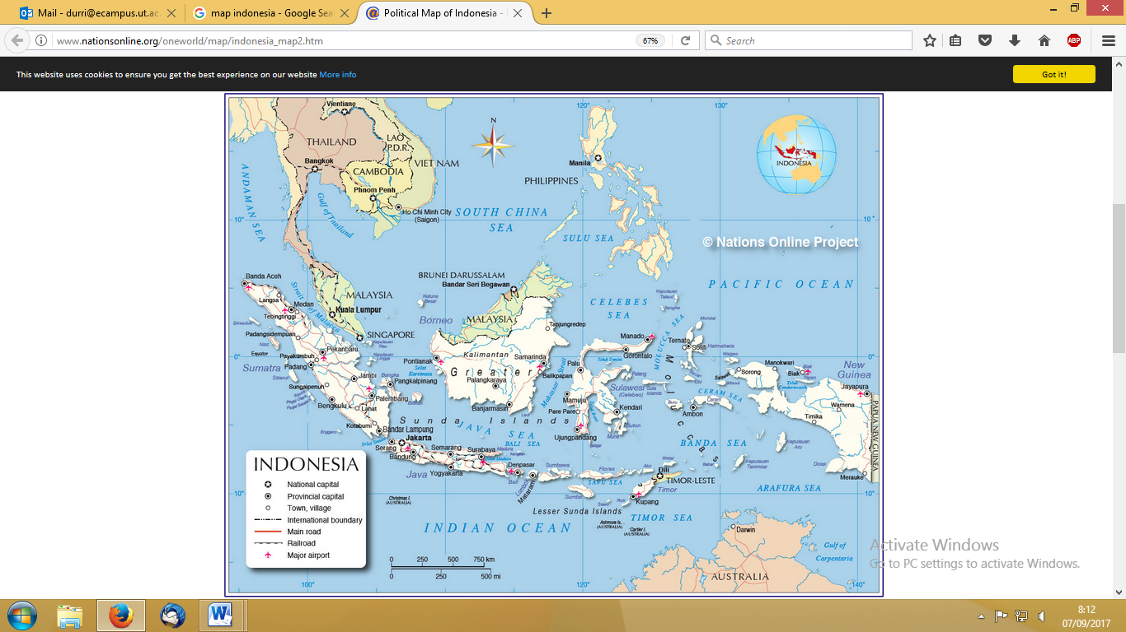

 UT RO

= Samarinda

= Ambon

= Sorong

 UT Headquarter

Source: [www.nationonline.org/oneworld/map/indonesia_map2.htm](http://www.nationonline.org/oneworld/map/indonesia_map2.htm)

Graph 1. Map of Indonesia

Graph 1 depicts area of Indonesia with its scattered islands. UT with its headquarter in Jakarta (yellow star - - in Graph 1) provides higher education for Indonesian elligible Indonesians no matter where they reside. This is possible because UT implement an open and distance education system which allow the use of media to deliver learning. Nevertheless, UT efforts to privide quality higher education to its students sometimes faced constraints due to limited infrastucures, especially in remote areas. At the same time, number of potential students in those areas are very high since they have limited access to conventional universities.

UT has provided basic educational facilities but students have to find ways to make the facilities work. UT students are also encouraged to implement self-directed learning in order to success in their study (Tim Penulis, 2017). Nonetheless, relying solely on infrastructure of UT to cater the educational needs for teachers in the all areas is not enough, especially those in eastern part of Indonesia. UT delivers learning materials to all areas but because of its remoteness, sometimes it takes longer to be received by students. UT also provides F2F tutorial but it is not easy to acquire qualified tutors in those remote areas.

Some of students combined the necessity for self-directed learning and limitation in infrastructure by forming study groups. In the study group, they implements collaborative learning while they share their understanding from modules provided by UT as well as link materials in modules with their expeuiences as teachers. These activities carry on even until those students have been graduated from UT. Aware of many challenges of being UT students in remote areas, they decided to keep on managing the study group, known as *Kelompok Belajar* or *Pokjar* for short.

This paper examines experiences of three *Pokjar* in three areas in eastern part of Indonesia that have evolved from small study groups to one that could facilitate a broader utilization of distance education in remote areas. What was first started with the objective to help themselves pursuing further education has become assets for other students. The *Pokjar* have played important part in increasing higher educational access using distance education system in remote areas for taechers.

**2 LOCATION OF THE *POKJAR***

Three *Pokjar* reported in this paper are *Pokjar* in Teluk Bintuni (West Papua province – see Graph 2),Tenggarong (East Kalimantan province – see Graph 3), and Tual (Maluku province – see Graph 4). These three *Pokjar* are located in eastern part of Indonesia which consists of thousands of islands where some can only be reached by sea or air. Even when the Pokjar can be easily reached, the students in that *Pokjar* come from thousands miles away from the *Pokjar*. For example, while Tenggarong is only one and half hour drive from Samarinda (UT RO in East Kalimantan province), some of the students have to drive for more than five hours to reach the location through wild jungles.

Table 2. Comparison of the Thee Pokjar in terms of Distance and Mode of Transportation Available

|  |  |  |  |  |
| --- | --- | --- | --- | --- |
| Location | Distance  (miles) | Mode of Transportation | Duration | Notes |
| Jakarta-Sorong | 1,723 | Air | 5 hours |  |
| Sorong-Teluk Bintuni | 400 | Air | 1,25 hours | Only available twice a week using small plane (12 passengers) |
| Air + Land | 1 hour + 12 Hours | Have to go to other town (manokwari) by plane first before continuing journey by land.  Students are scattered along smaller island in the areas and it takes hours to reach Teluk Bintuni by boat |
| Jakarta-Samarinda | 813 | Air | 3 hours |  |
| Samarinda-Tenggarong | 51 | Land | 1 hour | Students reside in amore remote areas and have to drive for hours through jungle to get to tenggarong city |
| Jakarta-Ambon | 1,479 | Air | 4 hours |  |
| Ambon-Tual | 344 | Land + sea | 2 hours + 3 hour | Using speed fery that heavely depended on weather to operate |

As can be seen in Table 2, distance from Jakarta (UT Hedquarter) to each UT ROs in this paper can only be reached by hours of flight. Not to mention that the students are not only coming from the area around the *Pokjar* but mostly come from miles away. For some stduents, the distance between *Pokjar* and students’ residences could only be travelled by sea (see Graph 4). Nevertheless, this condition did not make the students giving up, they still came to F2F tutorial sessions and did exam on schedules.

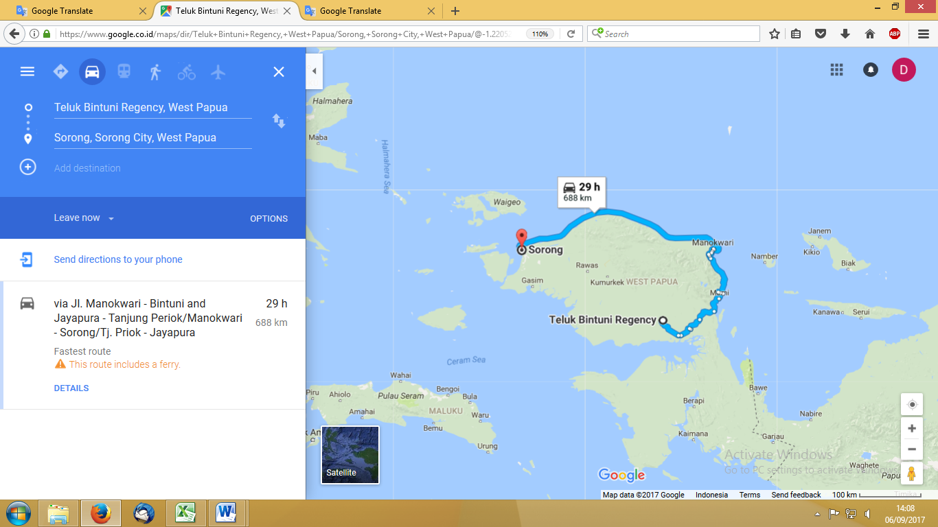

Graph 2. Map of Teluk Bintuni

*Pokjar* Teluk Bintuni manages UT students reside in surrounding small islands such as Number, Janem, Kakio, and Janawa. To go to Pokjat, students from the islands had to make a trip using a small boat owned by one of the students. And only if the weather is ok they can make the trip. While in Tenggarong, students have to go through wild jungle where they have to drive special vehicle. Nevertheless, students try very hard to come to F2F tutorial sessions which is conducted eight times in one semester. Meanwhile, to get to Tual from Ambon, one has to take speed boat for two hours followed by driving for three hours. Given thise condition, it is too difficult for UT ROs staff to provide F2F guidance.

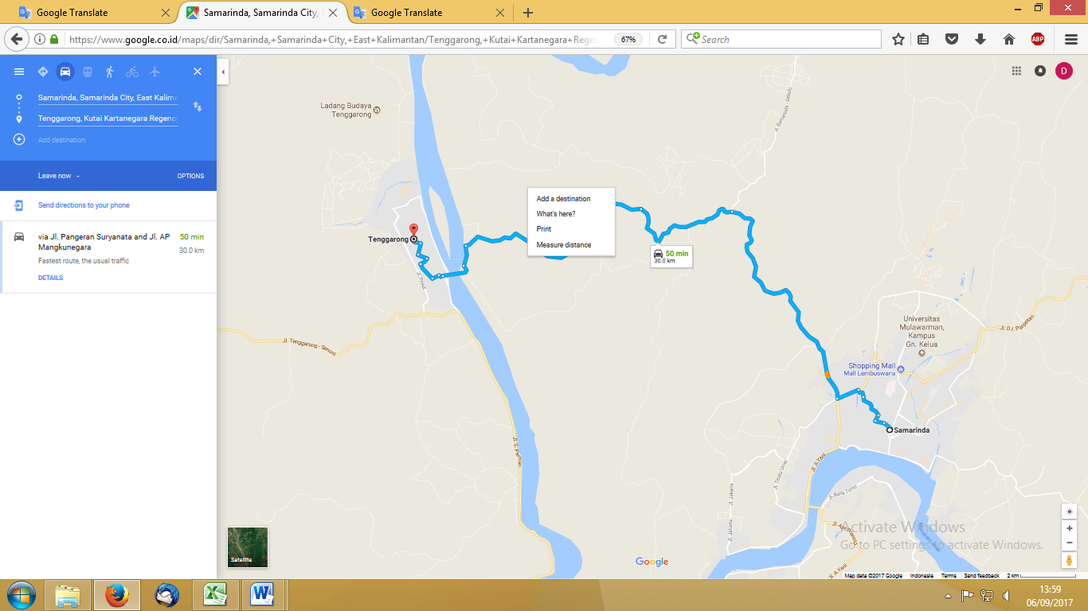

Graph 3. Map of Tenggarong

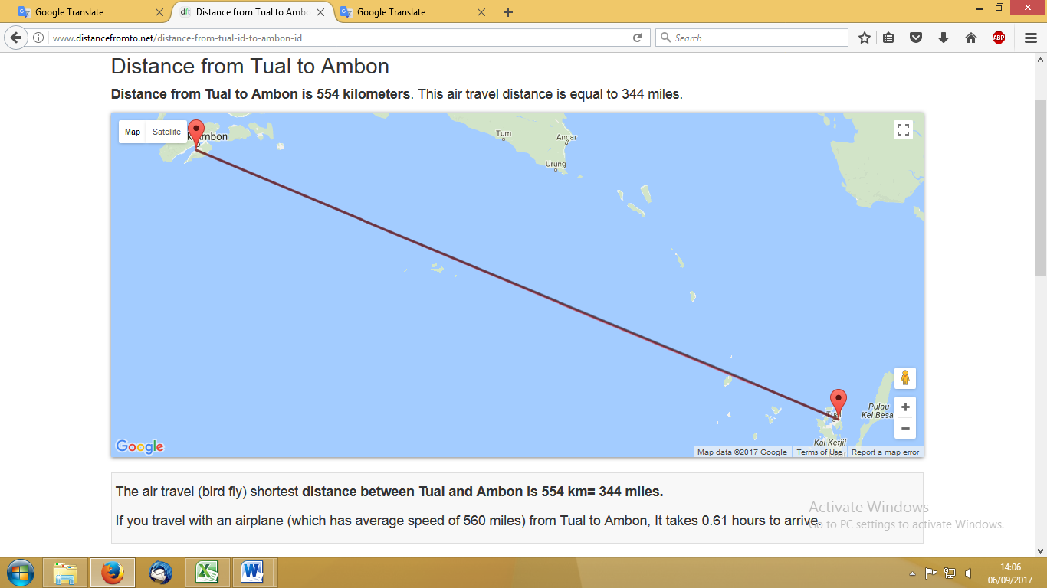

Graph 4. Map of Tual

However as Perreault, Waldman, Alexander & Zhao (2002 found out ) in their reaserch involving 61 professors, the greatest benefit of distance learning was flexibility for students and that student-centered teaching approach is necessary for successful distance-education courses, UT students get benefit from DE system and both UT and students have taken necessary measures to overcome constraints facing students in remote areas. Two of the measures are learning in groups and forming simple management that manages all administrative and learning processes as UT students.

**3 UT and *POKJAR***

UT provides its students with learning material, both in printed, recorded, and interned-based form with printed learning material covers all necessary material to master and pass a course. UT printed materials, known as modules, ara designed in such a way that could facilitate students learning. In addition, UT also provides learning support in various forms, such as F2F tutorial, online tutorial, and academic consultation. These facilities are intended for students so they can apply self didrected study. Nevertheless, some students find difficulties in mastering the learning materials. They need ‘teacher’ and they need some one to help them with tha learning process.

This is accordance with what Perraton (1988) beliefs as changes in distance ‘teacher’ roles. When the ‘teacher’ meets the distance students face-to-face, she now becomes a facilitator of learning, rather than a communicator of a fixed body of information. The learning process proceeds as knowledge building among teacher and students. Distance education systems now involve a high degree of interactivity between teacher and student, even in rural and isolated communities separated by perhaps thousands of miles. Beldarrain (2007) also states that although emerging technologies offer a vast range of opportunities for promoting collaboration in both synchronous and asynchronous learning environments, distance education programs around the globe face challenges that may limit or deter implementation of these technologies. Nonetheless, it is that that simple in the rural area in Indonesia. The technology, though developed, still could not reach all areas. Therefore Pokjar arises. Pokjar emerges and developes not only because of thechnology concerned but also to solve barriers, especialy those related to four of ten aspects mentioned by Muilenburg & Berge (2001), namely technical expertise, social interaction and quality, access, and student‐support services.

*Pokjar* can be seen, to some extent, as collaborative learning with its spesific assumptions about learners and the learning process. Collaborative learning has four assumtions, namely (1) learning is an active and constructive process (2) learning depends on rich contexts, (3) learning is inherently social, and (4) cooperation and teamwork also important in collaborative learning.

*Pokjar* implement peer teaching. Peer teaching is rooted in the one-room schoolhouse tradition, the process of students teaching their fellow students is probably the oldest form of collaborative learning. In recent decades, however, peer teaching approaches have proliferated in higher education, under many names and structures (Whitman, 1988). One of the most successful and widely adapted peer teaching models could be Learning Communities (Williams, Duray, & Reddy, 2006).

Lecture-based distance education could best be supplemented with various learning activities. Undergraduate volunteers participated in 1 of 3 post-distance-education lecture activities: individual study, cooperative learning, or interactive multimedia. Then they were tested on knowledge of lecture material and were asked how much they enjoyed the distance education experience. Results indicated that although the interactive multimedia group enjoyed the learning activity more than the cooperative learning and individual study groups, the cooperative learning group learned the most (Boling, Nancy C. Robinson, Daniel H. 1999).

To gain more understanding on the roles of *Pokjar* in increasing teachers’ access to higher education, this paper explains situations in three Pokjar located in esatern part of Indonesia, namely Teluk Bintuni, Tenggarong, and Tual. The Pokjar were chosen because of their location, remote areas and difficult to reach. This is a qualittative in nature where data were collected using interviews and further broken down into categories to analyze. Comparison and contrast are done to the results of interviews in the three *Pokjar* chosen. For each *Pokjar*, the leader and three students were interviewed. The interviews were done using intreviews guidance consist questions on students’ perception of the roles of *Pokjar* and whether there is something to be done to increase Pokjar roles in facilitating students’ learning process. The guidance were used loosely and interviewees were given liberty to talk about issues not mention in the guidance, if necessary. One of the interviewer was also a leader of Tenggarong *Pokjar*. Certain measures were taken to make sure that the interviews were done according to the guidance and not to make interviewee reluctant to provide honest opinions. There were three interviewers and before conducting interviews, thre interviewers followed an interrater agreement process to ensure that interviews were carried out in the same perspectives. The interviewes were done during March-August 2017.

**3 RESULTS & DISCUSSIONS**

In each of three *Pokjar*, interviews were successfully conducted with its leader and three students. All reviewees provided insight to Pokjar’s activities and the interviewees aslo provided inputs to perfecting *Pokjar*. Two of the *Pokjar* leaders started their involvelment with UT as students. As the time went on, they saw difficulties to communicate with UT RO because of distance and limitation in media available. Therefore they decided to start a *Pokjar* as means to help each others and finally keep on managing *Pokjar*, even after they graduated from UT. Leader at *Pokjar* in Tual, however, never been a students at UT but work as employee in the Education Unit in the Local Government. He was ordered to facilitate teachers during their study at UT.

Table 1 shows that all three *Pokjar* conducted similar activities in reletion to four of UT basic cores: registration, learning material, learning support, and examination. All three *Pokjar* carried out socialization, recruiting students, registering students, recruiting tutor, finding places for F2F tutoral as well as examination, and also bridging communication between students and respective UT ROs. Tenggarong *Pokjar* could reserve a place in one of the yunior high school in Tenggarong to conduct F2F tutorial and examinations. While in Teluk Bintuni, they can secure patnership with an elementary school. One thing stands out from the *Pokja* performance is that they had good relations with the local education office as well as with the school-principals in their areas. This good relationship help the *Pokjar* in securing places for F2F tutorial and exams.

*Pokjar* in Tenggarong and Teluk Bintuni stated that their biggest obstacle in managing *Pokjar* came from the community. In the early days of the *Pokjar*, people were less likely to appreciate UT because of the UT’s unconventional learning system. Now the condition has been changed and the community, including the principal and teachers, comes to *Pokja* to register as UT students. This condition has become one of *Pokjar's* biggest achievements. Meanwhile, *Pokjar* in Tual did not experience this problem because from the beginning UT was socialized by involving government officials, including decision to form Pokjar led by official.

Table 1. Perceptions of The Pokjar’s Leaders toward Their Roles



Meanwhile, in Table 2 and Table 3 there were data on students perceptions on their relation with *Pokjar*. Most of the students appreciated what *Pokjar* did to provide them with F2F tutorial and sometime in facilitating communication with the UT ROs. Students faced problems with UT mentioned *Pokjar* initiatives to solve the problems. However, used to be fully facilitated urged some students to ask Pokjar to slightly provide room for the students to communicate directly with UT ROs. Students also appreciated *Pokjar* for being able to provide easy and accessible F2F tutorial and exams sites. The sites can be reached by public transportation.

Table 2. Students Evaluations toward Pokjar



Aside form appreciation students give to *Pokjar*, students came up with several inputs to pergecting *Pokjar* performace. Students felt spoiled since *Pokjar* taking care of almost everything, administartive and academic issues of being students at UT. Being sopiled, some students felt that they lack of ability to use internet. UT provides administrative and academic information in print as well as via Interbet. Actually students are encouraged to check their mail and UT website regularly to keep up with the latest information. Nonetheless, since Pokjar had taken care of this, students did not do this. Eventually, students felt they loosing skills of utilizing the internet to seek information.

Table 3. Positive Things and Things That Need to be Improved about Pokjar



In Table 3, students mentioned several inputs for *Pokjar* to increase their roles in facllitating students. Some of the inputs were related to necssity for Pokjar to be more proactive and faster in solving problems with students’ marks.

**4 CONCLUSION**

From the students’ point of views, Pokjars have successful in helping the students to pursue higher educations. Pokjar could solve problems related to shortage in tutors, Pokjar could resolve difficulties related to finding and recruiting tutors to facilitate students learning were solved. In addition, Pokjar could provide places to conduct F2F tutorial and exams. Furthermore, Pokjars were highly appreciated for their roles in bridging communication between students and UT ROs, especially in resolving problems in exams.

Pokjar has played important roles to facilitating teachers in remote areas in the easrtern part of Indonesia to join higher education, so that not only the teachers could get their degree but also to build network with other teachers in the areas.

**REFERENCES**

[1] Astin, A. 1985. *Achieving Educational Excellence*. San Francisco, Jossey Bass.

[2] Beldarrain, Yoany. 2006. Distance Education Trends: Integrating new technologies to foster student interaction and collaboration. *Journal Distance Education*, 27(2), pp 139-153.

[3] Boling, N.C. & Robinson, D.H. 1999. Individual study, interactive multimedia, or cooperative learning: Which activity best supplements lecture-based distance education? *Journal of Educational Psychology*, 91(1), pp. 169-174.

[4] Bonwell, C. & Eison, J. 1991. Active Learning: Creating Excitement in the Classroom. ASHE-ERIC Higher Education Report (1). Downloaded from [*http://files.eric.ed.gov/fulltext/*](http://files.eric.ed.gov/fulltext/) *ED336049.pdf* on 11 Augusr 2017.

[5] Brown, J.S.; Collins, A. & Duguid, P. 1989. Situated Cognition and the Culture of Learning. Educational Researcher. 18 (1), pp. 32-42. Downloaded from [*https://people.ucsc.edu/~gwells*](https://people.ucsc.edu/~gwells) */Files/Courses_Folder/ED%20261%20Papers/Situated%20Cognition.pdf* on 12 August 2017

[6] Cohen, S. G., & Bailey, D. E. 1997. What makes teams work: Group effectiveness research from the shop floor to the executive suite. *Journal of Management*, 23, pp. 239-290. Google Scholar

[7] Golub, J. (Ed). 1988. *Focus on Collaborative Learning*. Urbana, IL: National Council of Teachers of English.

[8] Hernandez, S. A. 2002. Team learning in a marketing principles course: Cooperative structures that facilitate active learning and higher level thinking. *Journal of Marketing Education*, 24, pp. 73-85. Google Scholar

[9] Tim Katalog. 2017. Katalog 2017/2018. Tangerang Selatan: Universitas Terbuka

[10] Kuh, G.D.; Schuh, J.H. & Whitt, E.J. 1991. Involving Colleges: Successful Approaches to Fostering Student Learning and Development Outside the Classroom. San Francisco: Jossey-Bass.

[11] Muilenburg, L. & Berge, Z.L. 2001. Barriers to distance education: A factor‐analytic study. *American Journal of Distance Education*, 15(2), pp. 7-22.

[12] Perraton, H. (1988). A theory for distance education. In D. Sewart, D. Keegan, & B. Holmberg (Ed.), *Distance education: International perspectives* (pp. 34-45). New York: Routledge

[13] Perreault , H.; Waldman, L.; Alexander, M. & Zhao, J. 2002. Overcoming Barriers to Successful Delivery of Distance-Learning Courses. *Journal of Education for Business*, 77(6), pp. 313-318.

[14] Sherry, L. 1995. Issues in Distance Learning. International Jl. of Educational Telecommunications, 1(4), pp. 337-365

[15] United Nation. 2017. Inclusive, equitable and quality education’ at the heart of high-level UN event. Downloaded from *UN News Centre.* [*http://www.un.org/sustainabledevelopment/blog/ 2017/*](http://www.un.org/sustainabledevelopment/blog/%202017/)*06/inclusive-equitable-and-quality-education-at-the-heart-of-high-level-un-event/* on 9 July 2017.

[16] Viva. 19 Jun2 2017. Catat, Ini Jumlah Pulau di Indonesia yang Sebenarnya. Downloaded from http://www.viva.co.id/berita/nasional/927968-catat-ini-jumlah-pulau-di-indonesia-yang-sebenarnya on 25 August 2017

[17] Whitman, N.A.; Fife, J.D., Ed. 1998. Peer Teaching: To Teach is to Learn Twice. ASHE-ERIC Higher Education Report No.4,Washington, DC: ERIC Clearinghouse on Higher Education. Downloaded from *https://eric.ed.gov/?id=ED305016* on 10 August 2017.

[18] Williams, E.A.; Duray, R. & Reddy, V. August 1, 2006. Teamwork Orientation, Group Cohesiveness, and Student Learning: A Study of the Use of Teams in Online Distance Education. Journal of Management Education, 30(4), pp 592-616. Downloaded from [*http://journals.sagepub.com/doi/abs/10.1177/1052562905276740* on 12 August 2017](http://journals.sagepub.com/doi/abs/10.1177/1052562905276740%20on%2012%20August%202017)