FACTORS AFFECTING the Gpa OF AGRIBUSINESS students, IN UNIVERSITAS TERBUKA INDONESIA

Sri Yuniati Putri Koes Hardini1

1Universitas Terbuka (INDONESIA)

Abstract

The purpose of this study is to analyze the factors that affect the GPA of students who get Bidikmisi scholarship by using the Semester Package System (SPS) Plus service. SPS Plus is a package system of courses in study program where all courses taken in curriculum structure are arranged and offered on a package basis for each semester.

In general, UT students are not required to attend Face-to-Face (FtF) tutorial provided by UT, but for Bidikmisi scholars which use SPS Plus Services, they are required to attend FtF tutorial for all courses in the package. By following FtF tutorial, students are expected to get a high GPA, this is because they are new graduates from high school and the level of independence in terms of learning is still not so good.

GPA is influenced by two factors, namely individual factors and social factors. Individual factors consist of maturity/growth, intelligence, practice, motivation, and personality. While social factors can be seen from the condition of family, teachers and how to teach, the tools used for learning, environment, opportunities and social motivation.

The population of this research is 697 students of Bidikmisi scholarship program in Faculty of Mathematical and Sciences with SPS Plus service, and the sample used is 300 students of Agribusiness study program. The data were analyzed by using factor analysis, and the result in general GPA do not have correlation with internal and external factors, but GBA have correlation with internal and external factors in a group of GPA 2.50-2.75 and GPA 3.5 or more.

Keywords: GPA, Face-to-face tutorial, Semester Package System

# INTRODUCTION

One of the indicators of the success of a student in the study can be seen from the cumulative achievement grade point average (GPA) that they obtained. The student is said to be successful if they can get a high GPA score because with a high GPA they have and can fulfill one of the requirements required to get a job when they graduate or make it easier for them to continue their studies.

The high requirement of GPA is also one of the targets of the Universitas Terbuka (UT) in carrying out its learning process (UT 2010-20121 UT Strategic & Operational Planning, 2010). Because it is well known by the public that UT students or students who learn by using a distance-learning system that the average GPA that they obtained is lower than the student's GPA that is studying at university with a face-to-face learning system.

One of UT's efforts to improve students' GPA is by providing Semester Package Service (SPS) to their students.

## SPS

SPS is a program offering system where all courses in curriculum structure are arranged and offered on a package basis for every semester. SPS Service aims to guide students in choosing subjects and to take the study period to complete or pass on time, specifically 4 years and is expected to get higher GPA because all or part of the subject in the package must be tutored except those who use no-FTF SPS Service.

The SPS service is divided into four, (1) SPS Plus, (2) SPS Full, (3) SPS Semi, and (4) Non-FTF SPS (Katalog UT, 2015). Students that are using SPS service must form one group (class) in the same study program, except Non-FTF SPS. Because SPS Plus, Full, and Semi provide FTF services to students so that students' quota is required in order to hold one tutorial class. The three SPS models are usually given to students who receive scholarships.

SPS Plus is awarded to a newly graduated student who receives UT scholarship that is recruited from Senior High School that year and a year before, and must meet the requirements of having good academic performance but economically constrained. Those selected through the selection must meet the minimum number in one class of 20-30 people for getting FTF service for all the courses contained in the package. In addition, they also get training that is held at least once in each semester.

**1.2 GPA**

Many factors can affect the achievement of GPA, including internal factors and external factors.

1. Internal factors are factors that come from oneself that involves several aspects, among others: (1) physical aspects, for example is the condition of organ health, (2) psychological aspects, such as emotion, intellectualness, and motivation, and (3) Social Aspect, which is related to the socializing ability of students with the environment.
2. External factors, related to the variation and degree of difficulty of the material that is being studied, place of learning, climate, surrounding atmosphere, community learning culture and so forth (Purwanto, M.N,1984; Yusuf.S and Sugandhi, NM. 2011, Santrock, J.W. 2008)

Some of the problems that often arise in the implementation of distance learning, is that new students can not directly adjust to the distance learning model that must be self-regulating in terms learning and managing time so that many UT students fail to complete their studies timely.

By taking samples of Agribusiness study program students who receive Bidikmisi scholarships, this article will discuss how much of influence of internal factors (health, family conditions, and the ability of students to adapt to distance learning in UT) and external factors (how to learn, place of FTF, academic environment , and motivation to learn) that can affect the earning of GPA.

The function of this research is to see what factors that is most influential in the process of GPA earning on students who get scholarship using SPS Plus service that take the Agribusiness study, By knowing the most influential factor to the GPA, UT can improve the service so that the GPA can increase in accordance to what has been already targeted by UT.

# fRAMEWORK

The population of this research is 697 students from Faculty of Mathematical and Science who got Bidikmisi scholarship with SPS Plus service. Whereas, the sample is taken from 300 students Prodi Agribusiness. Data were obtained by using questionnaires and interviews.

The Data is processed from 147 questionnaires that are sent back and going through validation, then the data of valid respondents to use (N) is 140. The data are analyzed using factor analysis which is a technical system to look for factors that can explain relationship or correlation between various independent indicators that are observed to see what factors are most correlating to the earning of students' GPA grades using SPS Plus services.

**3 RESULT**

* 1. **Student Profile of Agribusiness Major**

Out of 140 respondents, their profiles are as follows in Picture 1. Respondents consist of students of Agribusiness study program which received Bidikmisi scholarship, using SPS Plus service and consist of 36% men and 64% women. The financial conditions, in general, are in accordance with what is required by Bidikmisi scholarship, average(57%) and poor (42%). They came from senior high school graduates (60%), and less than 30% are vocational school graduates, the rest are school graduates in addition to these two. Most of them came from Social Sciences (40%), while the Exact Sciences was only 35%, and the rest came from other majors. The year of their first registration is in 2013 (58%), and 26% by 2015, while only 12% enrolled in 2015.

Figure 1. Agribusiness Study Program Student Profiles

* 1. **GPA and Study Load**

Table 1. Description of GPA statistics and number of credits taken

|  |  |  |  |  |  |  |  |  |
| --- | --- | --- | --- | --- | --- | --- | --- | --- |
| Variable | Mean | St. Dev. | Skewness | Kurtosis | Minimum | Frequency | Maximum | Frequency |
| SCH | 103,40 | 30,04 | -0,685 | -0,633 | 14 | 1 | 134 | 30 |
| GPA | 3,05 | 0,55 | -0,063 | -1,092 | 1,91 | 1 | 3,98 | 1 |

SCH: Semester Credit Hours

From the data above, we can see the average picture and the minimal credits taken by students:

1. The average number of SCH is 103 with differences in the range of each other is about 30 credits.
2. Students who take the least credits which are 14 credits (only one student) and the most are 134 credits (30 students).
3. This can be explained because the respondents taken are the first registered students in 2013, 2014, and 2015. So they are in the 7th, 5th, and 3rd semesters at the time of data retrieval.

While the picture of student's GPA (respondent): can be seen as follows.

1. The average GPA of 3.05 with range difference of one with another (standard deviation) is about 0.55
2. The lowest GPA is 1.91 (one student) and the highest GPA is 3.98 (one student).

The histogram of the GPA and the number of credits taken by the student can be shown as in Figure 2 In Figure 2.(a) the distribution of SCH frequencies pursued indicates that there are three groups of total credits taken by students:

(1). There are 24 people (17.1%) who have taken <60 credits,

(2). 48 people (34.3%) who have taken about 60-110 credits, and

(3). 68 people (48.6%) have taken> 110 credits

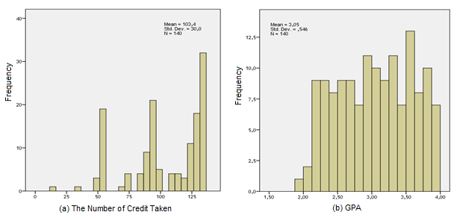

Figure 2. Histogram of Number of credits taken and GPA

While in Figure 2.(b) it is seen that the frequency distribution of GPA grades, shows a uniform distribution between the GPA grades ​​from low to high. If the GPA grades ​are grouped into several strata then the compositions are as follows:

Table 2. Composition of GPA by GPA Group

|  |  |  |  |  |  |
| --- | --- | --- | --- | --- | --- |
| **GPA Group** | | **Frequency** | | **Percentage** | |
|  | (1), < 2,5 | | **29** | | **20,7** | |
| (2). 2,5 - <2,75 | | **18** | | **12,9** | |
| (3). 2,75 - <3,00 | | **18** | | **12,9** | |
| (4). 3,00 - <3,50 | | **37** | | **26,4** | |
| (5). 3,5 – 4,00 | | **38** | | **27,1** | |
| Total | | **140** | | **100,0** | |

Distribution of GPA in various credits groups is presented in Figure 3 through the Boxplot diagram with the following results.

1. In group 1 (less than 60 credits), the GPA variations are small and generally being at GPA grades > 2.75. There are still four numbers of respondents who have a lower GPA than the group (<2.5).
2. In group 2 (60-110 credits), the earning of GPA starts to vary from 2.0 to above 3.5, with median 3.0.
3. In group 3 (more than 110 credits), the variation of GPA decreases with GPA grades mostly between 2.5 - 3.5 with median about 3.0.

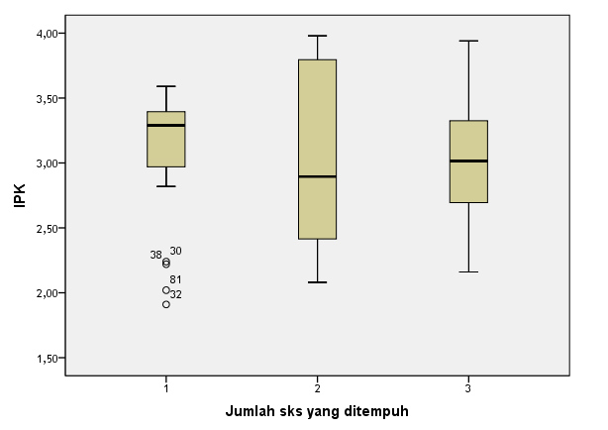

Figure 3. GPA Boxplot in groups of credits taken

(Credit Group: (1) <60 Credit, (2) 60-110 Credit, (3) >110 Credit)

* 1. **SPS Plus Service Factors**
     1. Course Selection

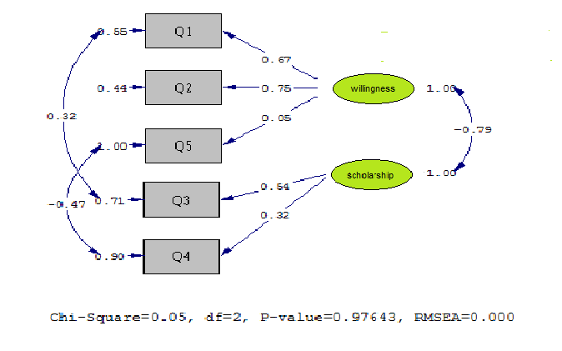

Figure 3. Path Diagram of course selection factors

Note:

|  |  |  |  |
| --- | --- | --- | --- |
| Q1 | I became a UT Student on my own choice | Q2 | I chose my own major based on personal choice |
| Q3 | I chose the study program as determined by UPBJJ although I do not like it | Q4 | I will take any major as long as I can get scholarship |
| **Q5** | I just choose the major that I like even without scholarship |  | Desire 🡪 Self-Desire Factor  Scholarship 🡪 Scholarship Factor |

* Running by Lisrel ver. 8.7

Response to the statement items (Q1 to Q5) on aspects of the selection service resulted in two factors, namely the willingness factor and the scholarship factor. The student's desire factor materialized when he became UT student and chose his own course of study. The scholarship factor materialized or fulfilled when he chose the study program.

1.3.2 Implementation of Face-to-face Tutorial

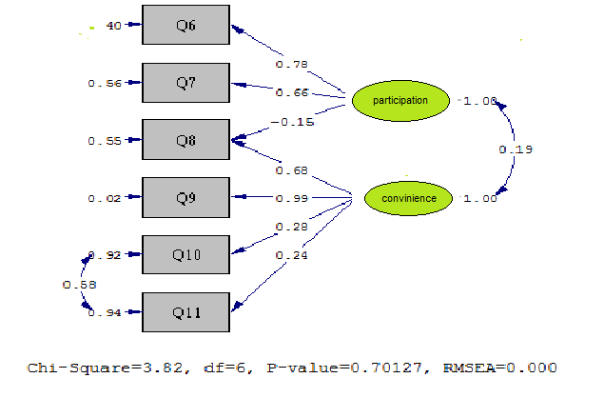

Figure 4. The path diagram of FTF service implementation factors

|  |  |  |
| --- | --- | --- |
| Note | |  |
| Q6 | FTF is conducted for every subject in each semester | Q9 | The Tutorial Location is easily accessible |
| Q7 | I always attend FTF for every subject | Q10 | The Tutorial Location is very comfortable for conducting class |
| Q8 | The location of the tutorial is near to my place of staying | Q11 | The facilities of tutorial room are comprehensive and very helping in conducting FTF |

Response to the statement items on the FTF service aspect also resulted in two factors, namely the factor of participation in the FTF and the convenience factor of the location and the FTF facility.

Participation factors are apparent in FTF services provided for all courses, but there is an indication that student participation in FTF is constrained by location (correlation -0.15).

The convenience factor is more emphasized on whether the location of the FTF is reachable and the distance from where the students live.

* + 1. Tutor

The response to the seven points (Q12-Q18) statement on the tutor's service aspects resulted in one factor, meaning all statements reflect the role of the tutor in implementing the FTF.

In another word, seven points of the tutor service aspect resulted in a one-factor score. In this case, the higher the tutorial score indicates the better the role of the tutor in implementing FTF. this can be seen in Figure 5.

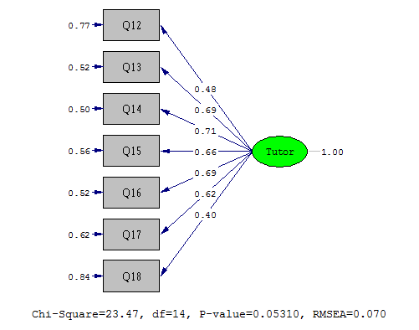

Figure 5. Path Diagram of tutor service aspect

|  |  |  |  |
| --- | --- | --- | --- |
| Note: | | | |
| Q12 | Tutor always comes on time | Q16 | In general, the practice of the tutorial is very pleasing |
| Q13 | In general, Tutor helps me understand all the course material | Q17 | All tutors do the tutorial well |
| Q14 | In general, Tutor motivates me to be more active in learning | Q18 | without a tutor, I will not get >2.5 for my GPA; Tutor, Tutor service |
| Q15 | In general, FTF Tasks that I follow are given feedback |  |  |

* + 1. Training

The response to the three points (Q19-Q21) statement on the training aspect resulted in one factor, meaning all statements reflect that training is indeed required by the student. In another word, the three aspects of training produce one factor. (see Figure 6).

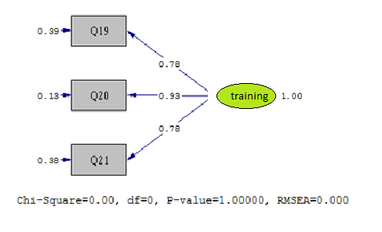

Figure 6. Path diagram of Additional Training Service

|  |  |  |  |
| --- | --- | --- | --- |
| Note: | |  |  |
| Q19 | I get additional training (motivation, entrepreneurship, etc.) every semester | Q20 | the training provided is in accordance with my subject/major |
| Q21 | the training provided adds to my motivation in learning | | |

* + 1. Number of credits in the package

The response to the three items (Q22-Q25) statement on the training aspect resulted in one factor, that is the number of credits in the package. The higher the score, the higher the credits load in the packet. This can be seen in Figure 7.

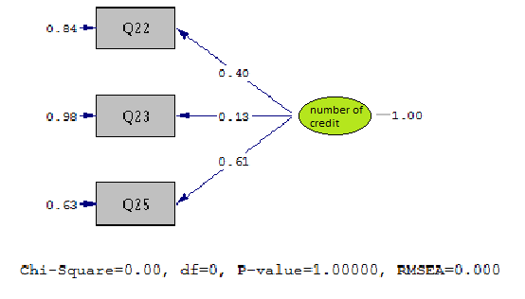

Figure 7. Path diagram of the study load factor (number of credits in the package)

|  |  |  |  |
| --- | --- | --- | --- |
| Note: |  |  |  |
| **Q22** | the number of credits in the package for each semester is sufficient | **Q25** | I always do a retest for the course with an E score in the next semester |
| **Q23** | I reduce the number of credits on the first and second semester packages, and adding those credits in the second year and so on | | |

* 1. **Impact of SPS Plus Service Factors**

Table 3. Statistics description of service factors.

|  |  |  |  |  |  |  |
| --- | --- | --- | --- | --- | --- | --- |
|  | Independent Variables | Standardized |  | t | Sig.  (*p*. value) | |
| No. | (Service factors) | Coefficients | Std. Error |
| 1 | Desire | -,174 | ,076 | -1,245 | ,215 |
| 2 | Scholarship | -,034 | ,075 | -,243 | ,809 |
| 3 | FTF Participation | ,128 | ,047 | 1,500 | ,136 |
| 4 | Convenience of FTF | ,118 | ,048 | 1,329 | ,186 |
| 5 | Tutor | ,084 | ,052 | ,886 | ,377 |
| 6 | Additional Training | ,165 | ,052 | 1,734 | ,085** |
| 7 | Number of Credits in package | -,175 | ,047 | -2,035 | ,044* |

Note:

Independent Variables: GPA; R2 = 0,114; F = 2,438 (*p*. 0,022). Running by IBM-SPSS ver. 20.

*) Significant on alpha 5%, **) Significant on alpha 10%.

Descriptive statistical analysis of the seven service factors in SPS Plus resulted in several important points as follows.

1. GPA is not influenced by conditions of desire, scholarship, FTF participation, the convenience of FTF facilities, and the role of tutor. This means that the implementation of FTF and Tutor services are running well.
2. GPA is affected (supplemented) by additional training factors (regression coefficient 0.165, p 0.085).
3. GPA is affected (inhibited) by the number of credits in the package (regression coefficient -0.175, p 0.044).

Table 4. Statistical regression of the influence of service factors on GPA for Group GPA 2.5-2.75 and GPA of 3.5 or more.

|  |  |  |  |  |  |  |
| --- | --- | --- | --- | --- | --- | --- |
|  |  | **GPA: 2,5 - 2,75 (b)** | |  | **GPA 3,5 or more (c)** | |
| No. | Variables (a) | Standardized Coefficients | Sig. |  | Standardized Coefficients | Sig. |
| 1 | Desire | ,956 | ,007 |  | ,469 | ,129 |
| 2 | Scholarship | 1,031 | ,008 |  | ,602 | ,040 |
| 3 | FTF Participation | -,519 | ,051 |  | -,224 | ,232 |
| 4 | Convenience of FTF | -,261 | ,181 |  | -,076 | ,671 |
| 5 | Tutor | -,116 | ,628 |  | ,226 | ,269 |
| 6 | Additional Training | ,590 | ,042 |  | -,159 | ,458 |
| 7 | Number of Credit in package | ,102 | ,600 |  | ,265 | ,153 |

Note: (a) Independent Variables: GPA; (b) R2 = 0,715; F = 3,575 (*p*. 0,034); (c) R2 = 0,205; F = 1,102; *p*. 0,387.

The statistical descriptive analysis shows that GPA is not influenced by the condition of factors desire, scholarship, FTF participation, the convenience of FTF facilities, and the role of tutor, but the regression analysis of group with GPA 2.5-2,75 and GPA of 3.5 or more, show differently as follows:

On the GPA: 2,5 - 2,75:

1. GPA is influenced by desire (p 0.007), scholarships (p 0.008), FTF participation (p 0.05), and additional training (0.042), at the level of significance of alpha 5%.
2. Determination model with seven other variables simultaneously significant, R2 = 0.715, p. 0.034.

On the GPA 3.5 or more:

1. GPA is only influenced by the scholarship factor (p 0.040), at the level of significance of alpha 5%.
2. Determination model with seven other variables (factor) simultaneously not significant, R2 = 0,205, p. 0.387.
   1. **Effect of SPS Plus student characteristics on GPA**
3. In general, there are internal factors that affect the GPA of Agribusiness study program students who use SPS Plus service as can be seen in Table 5, and the result can be concluded that the GPA is affected by Residential (p.0,000)), Condition of residence, p. 0.019), social condition, p.0.028), and school origin, p.0,075
4. If we see it based on its GPA group, then:
5. In the GPA group of 2.5-2.75, the student's GPA is affected by the residence (p.0.026)), the condition of residence, the financial condition of the family, the origin of the school, and the number of credits taken.
6. In the GPA group of 3.5 or more, the student's GPA is affected by the family financial condition, (p.0,002), social condition, (p.0,039), and the number of credits taken.

Table 5. Total, Average GPA, and comparison of the average GPA according to student characteristics



**4. CONCLUSION**

1. The correlation of internal factors to GPA of a student from Agribusiness study program using SPS Plus service are:
2. GPA is not influenced by the condition of factors by Residential (p.0,000), Condition of residence, (p.0.019), Social condition, p.0.028), and Original school, (p.0,075)
3. In the GPA group of 2.5-2.75, the student's GPA is affected by the residence (p.0.026), the condition of residence, the financial condition of the family, the origin of the school, and the number of credits taken.
4. In the GPA group of 3.5 or more, the student's GPA is affected by the family financial condition, (p.0,002), social condition, (p.0,039), and the number of credits taken.
5. The correlation of external factors to GPA are ;
6. GPA is not influenced by the condition of factors desire, scholarship, FTF participation, the convenience of FTF facilities, and the role of tutor.
7. On the GPA: 2,5 - 2,75:

GPA is influenced by desire (p 0.007), scholarships (p 0.008), FTF participation (p 0.05), and additional training (0.042), at the level of significance of alpha 5%.

1. On the GPA 3.5 or more:

GPA is only influenced by the scholarship factor (p 0.040 and alpha 0.05).

**REFERENCES [Arial, 12-point, bold, left alignment]**

1. Purwanto. M.N (1984). Psikologi Pendidikan. Remadja Karya, CV. Bandung.
2. Yusuf. S.L.N & Sugandhi, N.M (2011). Perkembangan Peserta Didik. PT. Raja Grafindo Persada. Jakarta.
3. Universitas Terbuka (2015). Katalog Universitas Terbuka.
4. Santrock. J.W (2009). Psikologi Pendidikan (Educational Psychology). Edisi 3. Buku 1. Salemba Humanika. Jakarta
5. Panduan Paket Arahan Prodi NonPendas, 2012 (Guide to Directed Packages for Non-Education Study programs 2012)”. (2012). Tangerang Selatan: Universitas Terbuka.
6. Rencana Strategis & Rencana Operasional UT 2010-2021. Versi Penyempurnaan (UT 2010-20121 UT Strategic & Operational Planning). (2010). Tangerang Selatan: Universitas Terbuka.