Model Development of Independent Exercises for Distance Learning in Mobile Platform Using Android Operating System
Djoko Rahardjo
¹Universitas Terbuka (INDONESIA)

Abstract
Independent Exercise is one of the Support Services for distance education students in Universitas Terbuka (UT). The students can download this learning application from the UT’s website. It is a mean for students to learn independently offline. Nevertheless, some students cannot reach it because of the limitations of computer devices and internet access. In fact, they have already equipped by themselves with the sophisticated mobile phone technology. This research was trying to develop an independent exercise model in mobile platform using Android operating system. The result was an Android application which then tested to the students. The test showed that students feel of the ease and benefits of using this application.
Keywords: independent exercise, android, model development

INTRODUCTION

Background
Higher distance education (HDE) requires students to study independently. Universitas Terbuka (UT) as an educational institution using HDE system provides various Learning Support Services for student learning process. According to Zuhairi et al. (2007) the provision of learning support systems is crucial in making students successful in distance learning.
One of the student learning support services is Independence Exercises (IE). IE provided at the UT Website (http://www.elearning.ut.ac.id/lm) using the SCORM program (Sharable Content Object Reference Model). To access the IE, students can download the courses as required. Students can use self-directed exercises that have been downloaded on their personal computers (PCs) offline. IE is generally a matter of multiple choice form of the course. This program can provide simple interaction automatically when students answer the questions given.
Rahardjo et.al (2016) found that low level of access to computers was the major factor for the lack of internet usage. While the weakness of the web-based IE is that the student must be in front of the PC, download it in the required course, then use it to practice answering questions in front of the PC. With this condition only 15% of students can access and work on IE.
The Indonesia Internet Service Provider Association (APJII) has report that there are 71.19 million internet users in Indonesia by the end of 2013. Based on survey result, APJII estimates that it is hard for Indonesia to achieve an alignment with the target of Millennium Development Growth (MDGs) which has also been agreed by the International Telecom Union (ITU), that in 2015 half population on earth must connected to the internet (Marius P & Pinontoan F, 2013).
Research conducted by Sigit et al. (2013) which uses short message system (SMS) in cellular phone as an independent learning tool which one of them is IE. The results showed that students who are in big cities and have literate internet media refuse the use of SMS, while students who live far from urban limited internet computer facilities feel helped by learning through this SMS.
Empowering students is a must for educational institutions, therefore researchers are motivated to develop a self-learning model based on mobile learning. By learning through Mobile Learning students are expected to learn anytime and wherever students have the opportunity to learn because the material to practice almost every time with him.
.

literature review

Higher Distance Education
Distance learning system has the characteristic of the absence of a face-to-face lecture system between faculty and students. Due to the absence of face-to-face meetings between the students and their teachers, one of the means to bridge the distance between them is the use of various media in the learning process. There are six characteristics in the distance learning system (Keegan, 1986), namely: (1) Separation of teachers and students; (2) The influence of an educational organization that distinguishes it from personal study; (3) The use of technical media; (4) Provision of two-way communication; (5) Possible meetings once in a while and (6) Participation in the form of educational industrialization.
The use of media in distance education is a pillar for the establishment of this type of education process. Media in distance education can serve as a means of communication between students and teachers, as a means of student learning media is the most powerful support to meet the needs of student learning process, and as a means for students to obtain basic information that is very important for students. Therefore, the use of Android-based equipment is one of the important alternatives of the media that exist among the students because the coverage of equipment is quite good.
IE is one of the learning support services in the form of questions along with feedback as a means of student practice doing semester exam. IE does not contribute to the final grade of the course. IE is only available online which is accessible to students on http://elearning.ut.ac.id/lm (Catalog UT, 2016).

Implementation of Mobile Learning
Mobile Learning is a new way of learning that uses mobile devices including handheld computers, mobile phones and smartphones that make learning all work (portable), spontaneous, personal and interesting. Mobile Learning relates to the mobility of learners, in the sense that learners should be able to engage in educational activities without the constraint of having to do so in strictly constrained physical locations (Kukulska-Hulme and Traxler, 2005). To some extent, learning outside the classroom or in the most necessary locations is the motivation to perform at every opportunity.
Woodil, G (2011) found that learners and tutors using mobile technology in their learning process include the following activities:
- Learners communicate with peers, tutors, and assessors.
- Learners who collect tasks in the form of video recordings, audio, and photo evidence for their portfolio.
- Tutors and assessors assess portfolio evidence and provide feedback.
- Learners gain access to learning content through a virtual learning environment or the internet.
- Additional resources and teaching materials provided via video.

Prototype of Independence Exercises Mobile Based Learning
The Android mobile operating system is an open source mobile platform Running on the Linux kernel Knapp, MM. And Lloyd, JK. (2010). Android applications in this study using online applications provided by MIT Android App Inventor 2, which is supported by Notepad text processing and image processing Inkscape 0.91. The use of the Android App Inventor 2 app makes it easy for programmers to code the program and not even an advanced programmer.
This LM SKOM4316 Android app generally consists of Android app and Text file that contains the problem of SKOM4316 and its key. The strutur textfile consists of: row1 stem no1, option a, option b, option, c option d, kunic no1 followed by the second row which is about no 2 with no such as problem no 1, and so on until the last number of LM .
The LM Android SKOM4321 application consists of 3 screens: Screen1 is a brief explanation of LM and its course, Screen2 contains LM issues randomly displayed so that students do not memorize LM numbers but rather memorize topics, in each student answer gets responses from apps, and Screen 3 Is a general report form of competence achieved by students and predictions raw score obtained.

methodology

Type of Research

This study is a research and development that produce a model. The acceptance rate of the model were measured by using the online survey method to see the trend of student acceptance of Independence Exercise Applications based on Mobile Learning.

Research Instrument and Testing

The instrument of this research is Independence Exercises Android application consisting of two courses namely Communication Innovation SKOM4316 and Public Opinion SKOM4321, and questionnaire of opinion about user acceptance of the application.

The poll instrument uses a list of questions that adapt from a question on the Technology Acceptance Model (TAM) from David (1989). Questionnaires include questions on: (1) Student assessment of ease of use in activities using Android-based LM. (2) Students' assessment of the benefits in activities using Android-based LM. The experiment of this research is applied to the students of Communication Studies Program from three UPBJJ areas namely UPBJJ-UT Malang, Surakarta and Bogor.

Research Procedures

This research generally consists of 6 main stages: (1) Application design, (2) Application creation, (3) Application extraction, (4) Application revision, (5) Distribution process, and (6) Polls of potential application users.

results

Results of Developing Model

General Model Designing
This Android IE app model refers to a mix of IE designs currently used by UT and some additional designs to enrich the app features. Its design consists of the following features:
- The number of questions is 45 questions in accordance with UT standard and the distribution of modular questions in UT’s textbooks.
- The Model provides are instructions for use on the opening screen. The adequate instructions will facilitate the users in doing this IE.
- The model has a choice of time to work 5 minutes, 20 minutes and 60 minutes. The working time selection in a session of exercise can be adjusted to the needs and time they have.
- Problems are randomly displayed on screen 2. With this randomization, the users iwill get different questions every exercise session. Thereby reducing the chance of user to memorize answer but more to understand the problem itself.
- The model provides feedbacks to strengthen student learning process. The feedback view is presented under questions and answers. Thus the user will be able to observe the questions, answers, and feedback at once in one screen.
- On screen 3, the Exercise Result Report appears and the conversion of the value obtained. Users will be given comments on the competencies achieved in one exercise session that students have been working on.

App Inventor Model Designing
Android applications in this study uses online Android applications provided by the Massachusetts Institute of Technology (MIT) App Inventor 2. This online software is the second generation that implements free or unpaid software. It does not look like the previous Android developer software program that's complicated and requires a lot of memory space and needs to learn for quite a while as a budding programmer. With App Inventor 2 software, a beginner can easily understand the structure and writing of programs in the development of an Android app. The use of the Android App Inventor 2 app makes it easy for programmers to code the program and not even an advanced programmer.
In the application development in this research, researchers use the supporting files to facilitate the use of this android application in the future, as well as facilitate the review of its IE materials. Support files in this application include text files that utilize Notepad or Microsoft Excel text processing. The researchers' graphic files utilize opensource image processing software Inkscape 0.91.
This LM SKOM4316 (Communication Innovation Courses) Android app generally consists of Android app and text file that contains the problem of SKOM4316 and its key. The text structure consists of: row1 stem no.1, option a, option b, option, c option d, key no.1 followed by the second row containing problem 2 with arrangement like problem no 1, and so on until the last number of exercises.
The LM SKOM4316 application consists of 3 screens: Screen1 is a brief explanation of LM and its course, Screen2 contains LM issues randomly displayed so that students do not memorize IE numbers but rather memorize topics. In each answer students will get response from application, and Screen 3 Is a general report form of competence achieved by students and predictions scores obtained.

Structure Design of Application
Design structure of the application consist of three screens, Opening Screen, problem or exercises Screen, and Evaluation. The opening screen consists of a preliminary explanation of the application and the courses presented. Views include explanations, Course overviews, and instructions on using the app. In this display provided a choice of practice time i.e. 5 minutes, 20 minutes and 60 minutes. In the application done a randomization of 45 questions to be displayed in the next screen. The Problem or Exercise Screen consists of the Course Title, the exercise question and the four answer questions. After answering the question by clicking one of the buttons A, B, C, or D, it will be shown feedback about the answer questions that have been selected. Also displayed is also a timer that runs so that users can adjust the speed of answering the given problem. Every time a student answers questions will be given feedback. The third scree is evaluation or report screen. The evaluation scree consists of the value obtained by users and comments about the application of user mastery or competence to the problem being done (See Figure 1).
Figure 1. Structure of Application

Developing the Model
Application development is done online with the website address http://ai2.appinventor.mit.edu/. Android app developers must register and use a gmail account. Although done through online, nevertheless the results of the application output is stored on the local computer. Display website Android Application Development with APP Inventor 2 can be seen in Figure 2.
Android Application Developer MIT App Inventor 2 features consist of four main features: Pallete, Viewer, Components, and Properties. Pallete is located on the left side of the user, while Viewer is in the center of the computer screen, and the last two features are displayed on the right side of the screen.
In the Viewer section can display two designs, graphic layout and text from the tablet screen or Android mobile phone designed, as well as program design written by the application developer. The design of this program is in the form of functional blocks, where each action performed by the user of the tablet is written. For example, the user presses or touches the button then the buttons of the program buttons act on certain commands in accordance with what is desired by the application developer.
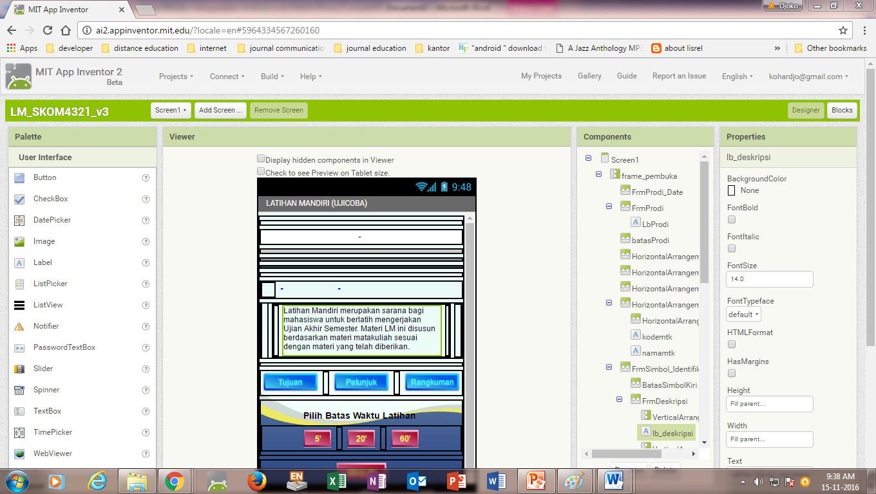
Figure 2. Students Distribution According to Their Regional Center

Opening Screen Design
Figure 3 shows an example of the Opening Screen display design and its block design view. In Designer Display consists of Title Text, general information about IE on SKOM4316 subjects, Destination Keys, Buttons, Course Summary Buttons. In addition, the option button time to do the exercises are 5 minutes, 20 minutes and 60 minutes Button. After the time selection button is pressed will be followed by the emergence of the Start Button. This means the user is ready to work on the exercises with the time limit they choose.

Support Screen Design
Support screen functions as additional information for users of this application. This support screen contains Application Instructions, Goals from app, and Course summary. All three features are controlled by the buttons on the Welcome screen. For example, if the Learning Objectives, or the Instruction or Summary Buttons are touched, it will display the appearance as desired by the user. On each display is provided Back Button that guides the users to return to the previous screen, the opening screen. In Appendixit can be seen the Designer Display and Block from the display screen of this IE.

Problem and Answer Screen Design
Once the user feels ready to practice by determining the time option, then the user can touch the Start Button. By pressing the Start Button, the user will be presented with the next screen which is the Problem Display Screen.
The next display is a screen design that displays the questions and four answer choices. This display design comes with instructions on working on questions and timers. After the user selects the answer by touching the A, B, C, or D keys, the user can touch the Check button on the bottom screen to lock the answer and to get feedback from the application. In addition to knowing the correct answer the user will also get feedback in the form of how many modules and learning activities where the problem is in the subject matter course on this IE.
The programming block does a randomization of the IE taken from the attached text file. This block also retains the answer key along with the feedback, so that the user's reply will be stored and matched with the recorded and calculated key which is then displayed in the next process.
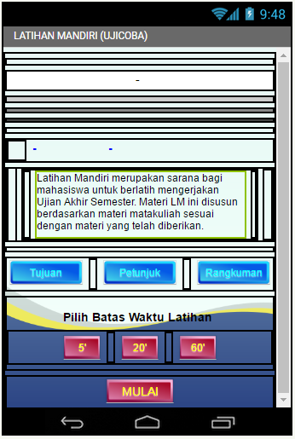
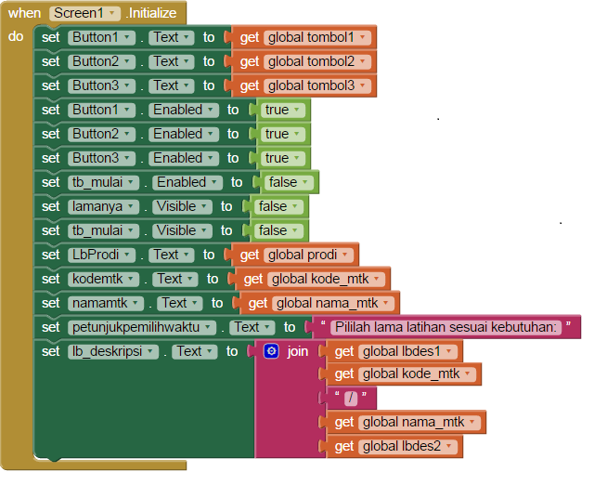

Figure 3. Left: Designer Screen, Right: Block Screen both in APP INVENTOR2

Evaluation Screen Design
The design on the Evaluation Screen section focuses on the user's answer and score 1 each time the user answers correctly. Problem will be recorded module number and number of learning activities. All module numbers and learning activities and conditions of true or incorrect user responses are displayed so that the user will obtain a thorough overview or map of the module's material satisfaction. By knowing this map, users can determine the next step in their learning process. Evaluation Screen Design on the Android-based application can be seen in Appendix.
The Evaluation screen comes with comments that contain general feedback on the achievements of the competence of users of the course. In addition, it also delivered a sentence that motivates users who encourage the next learning process.

Model Review
In order for the Independence Exercise application to be used as Indepence Exercise in accordance with the planned course, reviews was conducted which includes: (1) Independence exercises material, (2) screen dsiplay, and (3) application smoothness.
In this trial model of the Android-based Independence Exercise Application, the research uses two courses namely the Communication Program Innovation SKOM4316 and the Public Opinion SKOM4321 course. Both of the training materials and their feedback have been stated well by the material experts. The app screen view also gets expert reviews and expert advice has been accommodated by changing the view of it. The apps on Google Play are already on a revised version. Prior to launch to users this application was tested on several colleagues on the feasibility of this app for use by prospective users of UT students in particular.

Model Distribution
In order for this Independence Exercise application can be utilized by the user, the design result was changed into a package that can be operated on a Tablet or Smartphone. Designed application packages can be uploaded on the website, or installed on Google Play. In this research to distribute the application package to the respondent is done through Google Play and via Bluetooth available Mobile Phone.
Installation of the application package on Google Play requires certain requirements such as registration fee, free of advertising, free from activities the case of to differences in ethnicity, religious, beliefs, race and culture and free from third party demands. Another requirement for the developer is the graphical display and information that the developer should provide. This graphical display and information can be seen by potential users of the application at the beginning before the application is downloaded by potential users. In addition, application developers must prepare a screen image at various screen positions at least three photographs. In this research, there are six photo screen which consist of screen icon, opening screen, supporting information screen, time selection screen, display of questions and answers, and evaluation screen. Figure 7 is an app view already installed on Google Play. The leftmost image is the preview before the app is downloaded and installed by a potential user. The middle image is an example of a screen photo required by Google Play and the rightmost screen is general information about this app. The examples of photos that come from OPPO smartphone type A37f with 4 inch screen size.

User Poll Results
Polls on prospective applicants of Android-based IE applications are conducted in three UT Regional Center, namely Bogor, Surakarta and Malang. The distribution of students can be seen in Figure 4

Figure 4. Students Distribution According to Their Regional Center
The observation indicate that students who are generally students of this early semester seem interested in this android-based independent exercise application. In general, students have mobile phone equipment using android operating system. On the test site in three areas Regional center, students enthusiastic to immediately try this application despite the limitations of internet access fees.

Perceived Ease of Using Applications
According to the students, this android-based independent exercises app has features with interesting interaction characteristics, easy-to-understand instructions and easy-to-use applications where students' opinions are easily understood to be the lowest scores among the four questions raised in this poll. Ease of use is the most important requirement in an application and the students agree that this application is quite easy to use. Figure 5 shows the average percentage of respondents' opinions about the aspect of ease of use of the application.

Figure 5. Ease of Use the Application

Perceived Usefulness of the Application
In this poll student respondents were asked his opinion about the benefits of this application. The most prominent respondent opinion on the aspect of application usefulness is the application can be used in various places, then followed by the opinion that the application can improve the effectiveness of learning. The next five opinions of, respondents generally agree that the application can measure the development of learning, respondents can use feedback, respondents can increase motivation, respondents can improve understanding of subject matter, and the last respondents can adjust to the time. Figure 6 shows the average percentage of respondents' opinions on the benefits aspect using an android independence exercise.

Figure 6. Preceived of Usefulness the Application

Intent to Use the Application
Figure 7 shows the average percentage of respondents' opinions about the aspect of desire to use this android-based independence exercises application.
The respondent's most prominent opinion is that respondents wish to use the application with the aim of improving grade of the course. Student respondents strongly agree with this application so they plan to tell their colleagues. They also argue that will measure their competence by using this application.

Figure 7. Intent to Use of the Application

conclusions AND recommendations

Conclusions
The results of application development models and polls on the student can be concluded that the development of Independence Exercises model based on mobile learning using the Android application facilitated by App Inventor 2 in the course of Communication Studies Program Faculty of Social and Political Sciences of UT succeeded with marked by the acceptance of the app in Google Play and accepted by the student. Students' opinions generally accept this Android-based app as an easy-to-use application, containing good benefits for students and students wishing to use the app as part of their learning process.

Recomendations
Utilization of Android-based mobile phone that is quite evenly among UT students is sufficient capital for the development of learning support services. Therefore, the development of the Independence Exercises (IE) model on this basis becomes easy to deliver. With the use of Android-based applications, the institution also supports inclusive education more widely and easily accessible.
With the launch of MIT open source software such as APP INVENTOR2 this makes the Android application developers more facilitated in developing various types of applications, especially applications for education. Difficulties that have been generally complained by the Android application developers to be reduced. With the utilization of APP INVENTOR2. Engineering becomes much simpler
REFERENCES
- Alsofyani , MM et. al., (2012). A Preliminary evaluation of short blended online training workshop for tpack development using technology acceptance model : The Turkish Online Journal of Educational Technology. 11(3): 20-32
- Farida I & Yuliana E(2014). Sikap mahasiswa memanfaatkan teknologi informasi dan komunikasi dalam pembelajaran terbuka dan jarak jauh. Jurnal Pendidikan Terbuka dan Jarak Jauh, 15(2), pp. 112-121.
- Katalog UT. (2016) http://www.ut.ac.id/sites/all/files/images/pdf/Katalog_Sistem_ Penyelenggaraan_Non_Pendas_UT_2016.pdf
- Knapp, MM. & Lloyd, JK. (2010). Droid Does? Developments in the Android Medical App Market. Journal of Electronic Resources in Medical Libraries, 7, pp.247–253.
- Kukulska-Hulme, A dan Traxler, J. (editor) (2005) Mobile Learning: A handbook for educators and trainers. New York: The Routledge
- Mobile Learning Basic, http://wwwmobl21.com/Basics_Of_Mobile_Learning.pdf
- Ozata, FZ & Nilgun, OK, (2014). Students’ Preferences and Opinions On Design Of A Mobile Marketing Education Application. Turkish Online Journal Of Distance Education-Tojde 15 (1), p 14
- Sevillano-García, M. L., & Vázquez-Cano, E. (2015). The Impact of Digital Mobile Devices in Higher Education. Educational Technology & Society.18 (1), pp.106–118.
- Sigit, A, Yani DE & Pertiwi, PR (2013). Pemanfaatan latihan mandiri sebagai bahan tutorial bagi mahasiswa program studi agribisnis melalui fasilitas sms. Jurnal Pendidikan Terbuka dan Jarak Jauh, 14(1), pp. 1-12.
- Woodil, G. (2011). Tools and Technologies for Developing Your Teams: The Mobile earning Edge. New York: The McGraw-Hill Companies, Inc

Appendix
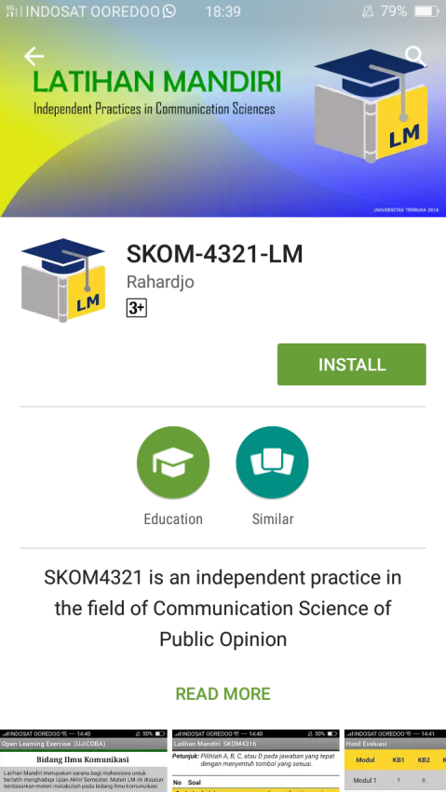 |  | 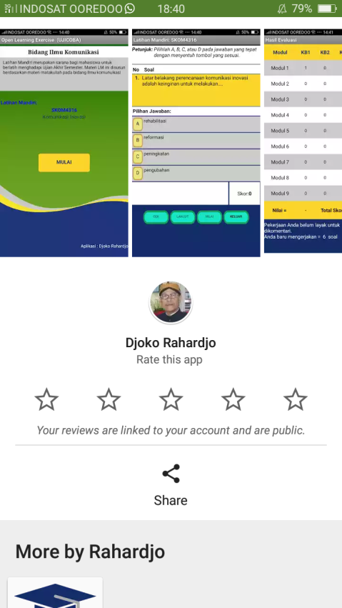 |  | 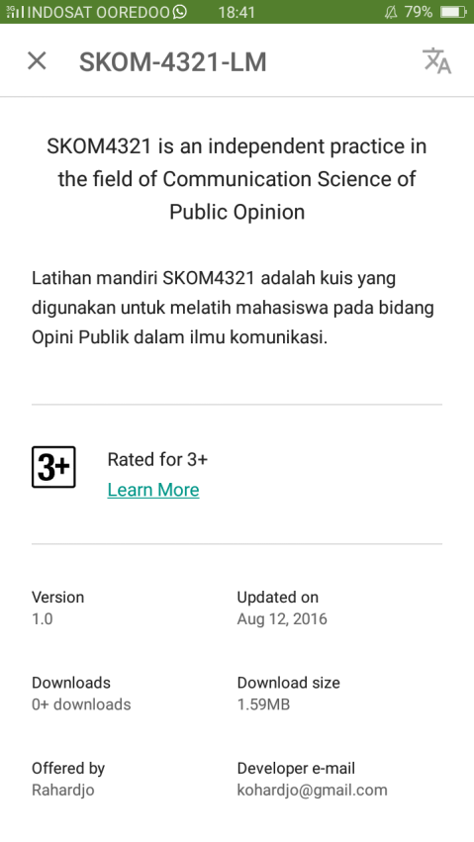
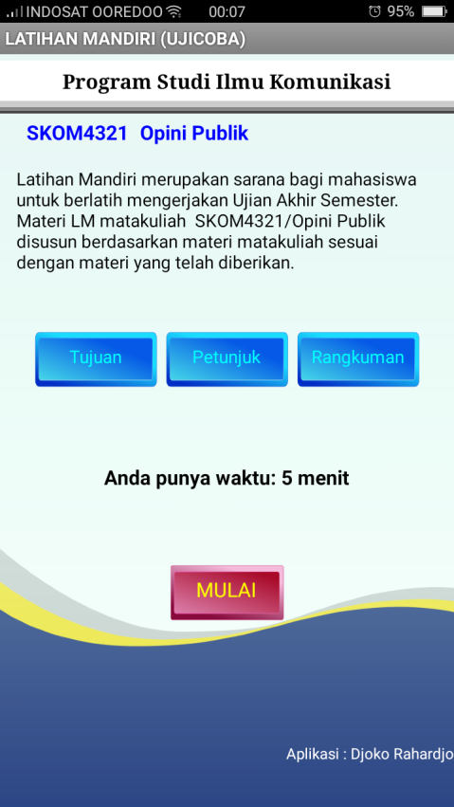 |  | 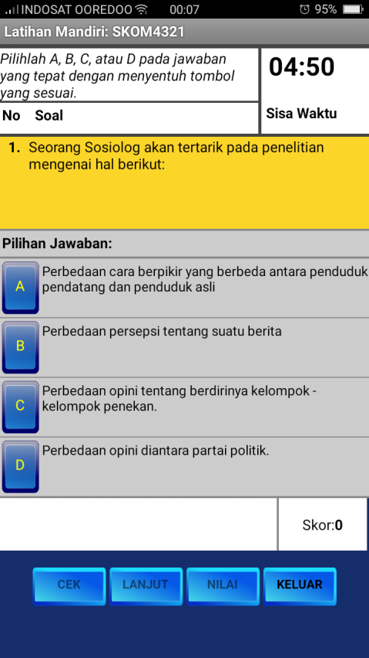 |  | 