Exploring Student Satisfaction and Behavioral Intention on Tutorial Online for Continuous Improvement Strategy of Universitas Terbuka’s
e-Learning System

Ginta Ginting (Ginta@ut.ac.id)
Department of Management, Faculty of Economics – Universitas Terbuka, Indonesia
Abstract
The rapid growth of internet-based technology/innovation has resulted in many approaches to learning development, manifested in different forms of e-learning. Universitas Terbuka/UT (Indonesian Open University) within a period of 15 years has been trying to optimize e-learning through online tutorial that plays an important role in improving the quality of learning process.
In order to assess tutorial online services requires more deep insight about student satisfaction and its impact on behavioral intention to participate in online tutorial. This study used three dependent quality variables (system, information and services) and two independent variable (satisfaction and behavioral intention). This study used survey questionnaire to collect data. The number of respondent participated in this study is 1252 students from Department of Management (Faculty of economics). Hyphotesis testing using Structural Equation Model (SEM) - Lisrel.
This study was able to prove that perceived satisfaction significantly influence system quality and information quality. Perceived satisfaction strongly influenced on the intention to use. The intention to use in this study showed a desire to reuse tutorial online, recommending and encouraging to others (friends) to use. Service quality did not significantly influence the perceived satisfaction. These finding indicate that the service quality that showed how instructors provide feedback, respond and always provide solutions to the problems of the participants did not affect satisfaction. For further research, there is need to observe more deeply determinant factors of service quality of online tutorial.
Keywords: E-learning, Tutorial Online, Quality, Satisfaction, Intention to Use.

Introduction
The rapid growth of internet-based technology/innovation has resulted in many approaches to learning development, manifested in different forms of e-learning. These often supplement or replace traditional methods, enabling students to enggange with their learning through various web technologies alongside or instead of face-to-face delivery (Al-Adwan et. Al, 2013). E-learning has been defined according to the context and environment where it operates (Jen et al, 2010). UT within a period of 15 years trying to optimize e-learning through online tutorial that plays an important role in improving the quality of learning process (Daulay and Zaman, 2012). Delivering quality learning process for UT is not easy because Indonesia is an archipelago country that spread from Sabang (East) to Merauke (West) (8.514 Kilometer). Under such kind of environment, online tutorial is a breakthrough to provide equitable education that is flexible, open and online to face with a challenge of globalization in education for prosperous society.
Online tutorial provides benefits for students as learning more communicative and interactive, the students receives a reply and feedback directly from tutors. Tutors have a very important role such as: 1) a manager, demonstrating commitment and professionalism, 2) a facilitator, providing feedback and helps students to develop study skills, 3) an assessor/evaluator, assessing students’ assignments, and 4) mentor, making students enthusiastic and participate actively. Online tutorials are considered to be successful if student participation is high. Several factors that can affect the students’ participation are the ability to use the internet, motivation and time allocation (Juleha, 2005). Reliable information technology is an important basis for supporting adaptive behavioral learning.
UT has 406.027 students, 68% is female and 32% is male (UT’s Profile, 2015). To support academics activities and administration, UT has 38 branches offices and foreign branches office handling overseas student (Saudi Arabia, Taiwan, Hongkong, Malaysia, Singapore etc). The number of students participating in online tutorial slightly increased from 108.942 (2013) to 226.479 (2014). The number of courses increased from 11 % (2013) to 52% (2014). Increasing number of participants indicates positive sign of service quality offered. The students’ participation in online tutorial cannot be separated from the role of tutors in encouraging students to be active learners through the development of contact intensity, cooperation, communication and responsive feedback. Online tutorial needs support of reliable IT infratructure due to its responsive internet design, where technology is the basis of instructional design to change online tutorial into adaptive learning behavioral.
Since online tutorial was offered in 2001, there are still many challenges in improving its quality. Several empirical studies on the effectivity on online tutorial from several Department in UT resulted in various findings in the field, namely: 1) students’ difficulty to access, 2) low participation due to limited internet facilities, 3) the lack of tutors’ role in managing online tutorial indicated by not uploading initiation on time, lack in providing feedback and less responsive in responding discussion forum, 4) low interaction between tutors and students (Fatia et al, 2012, Dewatisari, et al, 2010, Budiwati, 2007).
The challenges to improve the quality of online tutorial in the future increases, particularly for Department of Managemenet – Faculty of Economics UT, because since 2015.1 (Semester 1 in 2015) it has to involve outsourcing lecturers to increase the quality of online tutorial. Total class followed by students of 2015.1 is 428. By the Decree of Rector, every supporting lecturer/tutor in each Department or study program is obliged to manage 4 online tutorial classes, therefore in total, there are 428 classes managed by Department of Management. The success of the implementation online tutorial by lecturers (both UT’s lecture and outcoursing lecture) will depend on the readiness of the tutors in managing online tutorials. There are three important stages in managing online tutorials are preparation, implementation and evaluation. In order to be able to implementing online tutorials effectively, tutors are required to make preparation regarding the materials, understand the procedure and guidance of online tutorials as well as follow trainings. In the implementation stage, tutors are required to prepare and send 8 initiation materials (8 weeks), assign assignments (3 times), discuss and provide feedback to students. After the implementation of online tutorials, tutors are required to provide assessment. Tutors with the ability in terms of content and reliable information system infractructure support become important factors in influencing the quality of online tutorials.
In terms of participants, the quality of online tutorials can be measured from perceived satisfaction which affects the intention to use such as recommending and encouraging friends/relatives to participate, speading positive benefits gained from online tutorials and having the will to take benefit of online tutorials to support learning process. Intention to use of online tutorial participations can be influenced by four determinants namely perceived satisfaction, quality information, quality system and service quality. Perceived satisfaction is an important factor in online tutorials because it relates to success continuous usage. Quality information relates to material substance which can provide useful knowledge. Quality system relates to accessibility namely ease, flexibility and information sharing with community. Service quality relates to tutor responds in the forms of discussion, feedback, update content and problem solving.
In order to gain a deeper insight about online tutorial quality services, it is necessary to investigate five important determinant variables such namely behavioral intention, perceived satisfaction, service quality, system quality and information quality. Online tutorial quality service is an important determinant factors for withdrawal and persistence in distance education (Zeithalm and Bitner, 2000; Saleh et al 2012; Liaw, 2007; Somers, 205).

Conceptual Framework and Research Hyphotesis
Figure 1 depicts the proposed conceptual model. This model derive from the literature that examines the relationships among quality variables (system, information, service), perceived satisfaction and behavioral intention (Ajzen dan Fishbein, 1980; Davis,1989; Parasuraman, Zeithmal dan Berry, 2000; Taylor and Todd, 1995; Ajzen dan Icek, 1991). As can be seen, the major construct in the model are system quality, information quality, service quality, perceived satisfaction and intention to use. This model suggests that perceived satisfaction and intention to use are influenced directly by system quality, information quality and service quality. Intention to use directly influenced perceived satisfation.
Figure 1: The Conceptual Model
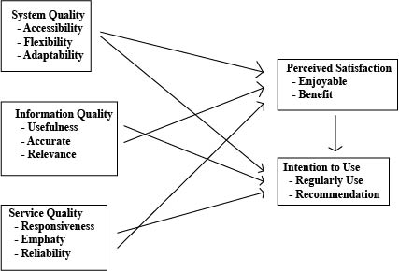
System Quality
System quality is an inherent characteristic of information about the system itself referring to how well the capabilities of hardware, software, and procedural policies of information systems can provide the user information needs (Delone and Mc Lean, 1992). Jogiyanto (2007) stated that the system quality is used to measure the quality of technology itself. Other expert, Chen (2010) proposed that the system quality is a measure of the processing of information system. In e-learning context, system quality is a functional aspect quality of e-learning, referring to several aspects, namely: accuracy, convinience, efficiency, flexibility, reliability and responsiveness (Cheng, 2012). According to Islam (2010) System quality is “the general perception of a system in terms of its performance and this is reflected by various systems”.
Chen (2010) elaborated that system quality can be measured through 5 dimensions, namely: 1) system reliability, measuring the reliability of the system operated; 2) system flexibility, the system can adjust to various user needs and the changing conditions; 3) system integration, the system makes it easy to combine data from various sources to support business decision making; 4) system accessibility, the ease to access information; 5) system time respond, assuming a rapid or timely system respond to requests of infomation.
In e-learning context, sistem quality is measured with functionality system which is a perceived ability towards e-learning system to provide a flexible access on instructional aspects and media assessment. Islam (2010) stated there are 3 factors influencing system quality, namely accessibility, ease of use and reliability. Accesibility is a level of accessibility, ease of use is the level to which every individual is easy to use e-learning. Reliability is the dependability of the e-learning system operation. Lee, Shin and Lee (2009) stated that there are several factors concerning system quality namely flexibility, integration, response time, sophistication, reliability, accessibility, usability, and ease use. The definition used in this study is the quality of information technology system used based on users’ perception. System quality in this study is measured by accesibility, flexibility and adaptability.
Several study results (Zeithalm, 2000; Lee, Shin and Lee, 2009; Islam,2010) can prove that system quality affects perceived satisfaction, which will affect behavioral intention (Davis,1989; Ajzen and Icek, 1991; Cheng, 2012). Based on theories, concepts, and supports of several empirical researches, two hypothesis were proposed:
Hypotheses 1a: System quality has a positive direct effect on perceived satisfaction in terms of enjoyable and benefit

Hypotheses 1b: System quality has a positive direct effect on intention to use expressed in terms of regularl usage and recomendation.

Information Quality
Information quality is the degree where information has content, form, and time characteristics which gives a value to certain end users (O’Briens, 2005). A system of IT usage should be able to provide information to support decision making in a company/organization (Seddon,1997). According to O’Briens (2005), information quality can be interpreted as measurement of content quality of information system. Jogiyanto (2005) describes that information quality consists of three things namely: 1) accuracy, information should be free from mistakes and not biased; 2) in a timely manner, information received by recipient should not come late; 3) relevant, available information has value in accordance with the required benefit of users.
In the context of e-learning quality, information indicates the quality of the content. The quality of information is measured using a accuracy, completeness, efficiency, relevance and timeliness information dimensions (Roca et al, 2006). Information quality intended in this research is the user's perception of the quality of information on online tutorials. Information quality measurements used are usefulness, accurate and relevance aspects.
Some study results (Zeithalm, 2000; Jogiyanto, 2005) prove that the information quality can affect the perceived satisfaction which in turn affects behavioral intention (Davis, 1989; Ajzen and Icek, 1991; O'Brien, 2005). Based on the theories, concepts and support of some empirical researches, there are two hypothesis proposed.
Hypotheses 2a: Information quality has a positive direct effect on perceived satisfaction in terms of enjoyable and benefit

Hypotheses 2b: Information quality has a positive direct effect on intention to use expressed in terms of regularly use and recomendation.

Service Quality
One of the factors that determine the level of succes and quality of an institution is its ability to provide services to customers. The success of a company in providing quality services to its customer, high achievement in market share, as well as the increasing profit is largely determined by the approach of service quality used (Parasuraman, Zeithmal dan Berry, 2000). The consequence of the service quality approach of a product is essential for company strategy to maintain itself and be successful in facing competition. One of the service quality approaches broadly referred to in service marketing reseaches is SERVQUAL (Service Quality) model developed by Parasuraman, Zeithalm, and Berry (2000) in a series of their studies in six service sectors, namely repair, household appliances, credit cards, insurance, long-distance calls, retail banking, and security brokers. There are five important dimensions of SERVQUAL for service, namely: tangibles, reliability, responsiveness, assurance and emphaty.
SERVQUAL is built based on the comparison of two main factors, namely customer’s perception on the tangible service they receive (perceived service) and the actual service expected/desired (expected service). If the reality exceeds expectation, the service can be regarded to have quality, on the other hand, if the reality is not as expected, the service is regarded to have no quality. And if the reality fulfills expectation, the service is called satisfactory. Therefore, service quality can be defined as how extent to which the reality differs from customer expectations on the service they perceive (Parasuraman, et.al, 2000). Customers’ expectaction is basically the same with the service that is supposed to be given by company to its customers. This customers’ expectation is based on the information submitted by word of mouth, personal needs, past experience and external communication (advertisements and various forms of company promotion).
In e-learning context, service quality can be categorized as the support provided by instructors technicians for the learning process to go smoothly. Cheng (2012) defines service quality “as the degree to which a user perceives that the overall quality of services”. This study defines service quality as the quality service perceived by online tutorial participants during the interaction with the instructor. The dimensions used to measure service quality are reliability, responsiveness and emphaty.
Several studies (Gounaris et al, 2008; Cristobel and Guinaliu, 2007; 2001; Zeithalm, 2002) can prove that service quality affects satisfaction which will affect behavioral intention (Ajzen and Fishbein, 1975; Davis and Ventakesh, 1991, Ajzen and Icek, 1991; Boston Consulting Group’s Study, 2001). According to theories, concepts and supports of several empirical researches, there are two hypotheses proposed, namely:
Hypotheses 3a: Service quality has a positive direct effect on perceived satisfaction in terms of enjoyment and benefit

Hypotheses 3b: Service quality has a positive direct effect on intention to use expressed in terms of regularly use and recomendation.

Perceived Satisfaction and Behaviroal Intention
Providing customer satisfaction is one of the strategies to maintaining the viability of the company. Customer satisfaction is influenced perceptions and feelings (perceived satisfaction). Perceived satisfaction is defined as a sense of satisfaction for what is expected to exceed reality (Kotler, 2010). The relationship between customer satisfaction and customer expectations can be seen on the following formula: Perceived Satisfaction = Performance – Expectation. If performance exceeds expectations, the customer will feel very satisfied.
The determining factor for customer satisfaction is the customers' perception of service quality (Zeithalm and Bitner, 2000). If further reviewed, providing customer satisfaction can be done by improving service quality. According to Kotler (2010) there are several approaches that can be done namely: 1) minimizing gaps that occur between management and customers. 2) the company must be able to build a shared commitment to create a vision in the service of process improvement. 3) giving customers the opportunity to submit a complaint by forming the complaint and suggestion system, for example with a toll-free hotline. 4) developing and implementing accountable, proactive, and marketing partnership in accordance with the marketing situation.
In e-learning context, construct of perceived satisfaction is often used in various studies. Saleh et al (2012) defines the perceived satisfaction as the degree of user satisfaction on the software used and the output generated by the software. Liaw (2007) proposes that a satisfaction feeling of e-learning users can increase participation in the learning process, e-learning activity provides a great opportunity for users and instructors to share experiences and knowledge. According to Jogiyanto, user satisfaction is user respond against information system outcome use. Somers et al (2005) defines perceived satisfaction as an affective attitude towards a particular software application by a person who interacts directly with a computer. Perceived satisfaction measurements used in this study was participants’ attitude toward system interaction and benefits gained. Dimensional measurements used were benefit and enjoyable aspects.
Some classical theories can prove that the satisfaction has a positive impact on behavioral intention (Intention To Use). Behavioral Intention is an important mediator variable related to the behavior in influencing the actual use. Theories that use behavioral attention construct is the Theory of Reasoned Action (TRA) (Ajzen, 1975); Theory of Planned Behavior (TPB) (Ajzen and Fishbein, 1980); Decomposed TPB (Taylor and Todd, 1995) and Technology Aceptance Model (TAM) (Davis, 1989). Behavioral attention is the variable that causes the behavior of an attitude and becomes an influencing mediator of various motivational factors that have an impact on behavior. In addition, the intention also shows how hard a person dare to try, how much effort is planned for someone to do, and the most influential intention for another behavior is the behavior of real use to product/ services (Ajzen and Icek, 1991).
The intention to perform a behavior (intention to use) is the tendency of a person to choose to do or abstain from doing any act. This intention is determined by the extent to which the individual has a positive attitude to a certain behavior, and the extent to which the choice to perform these behaviors have the support of others who are influential in their lives. TPB concludes that the goal is the dominant factor in determining the decision to act or not. All factors that could influence actual behavior are a manifestation of indirect influence on behavioral objectives. In the context of the behavior of the use of technology, two experts Davis (1989) and Davis and Ventakesh (1991) suggest the Technology Acceptance Model (TAM) using three important constructs as predictors that influence the intention, namely: perceived usefulness, perceived ease of use and attitude. TAM is widely used to predict a person's behavior in relation to the use of technology.
In e-learning context, some studies used behavioral intention construct to be able to measure the extent to which the effectiveness of the learning process has been workable. A study of Chen (2011) showed that the quality (information, systems and services) are important determinants that may affect the acceptance of e-learning. Then Ho (2009) suggests that the determinants of e-learning outcomes is the quality system, technology readiness and learning behavior. Learning outcomes in this case are related to skill development and satisfaction. Ma et al (2013) defines behavioral intention as the intention to continue using e-learning which is affected by factors of ease of use, quality of information and benefits. Chen et al (2011: 1596) states that "intention of use of e-learning is influenced by the benefit of innovative technology and affect satisfaction". This study defines the behavioral intention (intention to use) as the intention to use the online tutotial as a part of a self-learning activity. Operational measures used are self learning (regularly use) and recommendation.
Based on the theories, concepts and empirical research support, there is a hypotheses can be proposed, namely:
Hypotheses 4: Perceived satisfaction has a positive direct effect on intention to use expressed in terms of regularly use and recomendation.

Research Methodology
The method used in this research is descriptive and verification (Cooper and Schindler, 2011: 155). The verification method is used by applying explanatory research method to explain the nature of causal relationships through hypotheses testings. To obtain research data, survey method was used. In this study, the target population was participants of online tutorial of UT guidance by lecturers of UT and outsourcing lecturers of period 2015 (semester 1 and 2). Sampling in this study was done by using stratified random sampling based on several considerations, namely: 1) The representativeness of the sample thus improving the efficiency of statistics, 2) provision of sufficient data to analyze the various strata (Cooper and Schindler, 2011: 379). Method of sample selection was done by proportional-random sampling. Determination of the sample was done by using recommendations from Hair et al (2014). Sample size was determined by the maximum number of arrows pointing at the construct (Hair et al (2014: 21), which this study was amounted 7. With a significance level of 5%, the minimum number of samples of respondents was of 80, the distribution was based on the proportional allocation, namely the spread on a comparable basis in accordance with the courses taken by the participants. For the purposes of this study, data were collected by using a questionnaire that had been prepared for respondents. This study used verification as analytical method. Verification analysis was used to test the hypotheses by using statistical tests with Covarians-based SEM-LISREL designed to solve complex multiple regression (Vinzi 2010: 308).

Analisis and Discussion
The number of respondents participated in this study was 1252 people. Questionnaires were distributed by email to the target respondents, which are students of Management Department/Study Program participating in online tutorials. Based on sex, there were 51% of female respondents and 49% of male. In terms of age, the range of the respondents was over 21 years (83%), which was dominated by oline tutorial participants aged 21-25 years (37.6%).
Table 1: Characteristics of Respondent
Question | Detail | Proportion
Sex | Male | 49.0%
 | Female | 51.0%
Age | Under 21 years old | 17.0%
 | 21 - 25 years old | 37.6%
 | 26 - 30 years old | 21.6%
 | Above 30 years old | 23.6%

In terms of UPBJJ-UT (UT’s Regional office) where student came from, it found that the respondents came from almost all UPBJJ-UT included UPBJJ-UT abroad. In terms of frequency, respondents were dominated by students from five UPBJJ-UT namely Jakarta (15.3%), Bandung (5.8%) followed by Bogor and Batam, which reached 5.8%. Profile of respondents indicated that sample data was fairly representative to represent the population namely entire student population representing management Department/Study Progam which followed online tutorial of UT.
Analisis Structural Equation Modelling
In table 2, it can be seen the calculation of goodness of fit/ GOF (suitability test model) of 1252 respondents. SEM-lisrel requires to test model fit. GOF measurements show that the model planned is good and fit because after it has been tested for its suitability, its value is concidered as good and marginal than the cut off value. Thus, theoretically and conceptually, the model proposed or developed in research framework was supported by empirical conditions. Calculation result showed that the value of GOF is 8 and the size of GOF showed a good suitability, on the other had 7 other GOF showed less suitability. Therefore, it can be concluded in overall that the suitability of the model was good.

Tabel 2: Goodness of Fit Model | Figure 2: Model Estimates
Ukuran GoF Target Tingkat Kecocokan Hasil Estimasi Tingkat Kecocokan  Chi – Square P P > 0,05 X² = 2992.81 (P = 0.0) Not Good  NCP Interval 2813.81 (2640.15 ; 2994.80) Fair  RMSEA p (close fit) RMSEA ≤ 0.08 p ≥ 0.50 0.11 p = 0.00 Not Good  NFI NFI ≥ 0.90 0.96 Good  NNFI NNFI ≥ 0.90 0.95 Good  CFI CFI ≥ 0.90 0.96 Good  IFI IFI ≥ 0.90 0.96 Good  RFI RFI ≥ 0.90 0.95 Good  CN CNI ≥ 200 111.67 Not Good  RMR Standardized RMR ≤ 0.05 0.081 Fair  GFI GFI ≥ 0.90 0.81 Fair  AGFI AGFI ≥ 0.90 0.76 Fair | 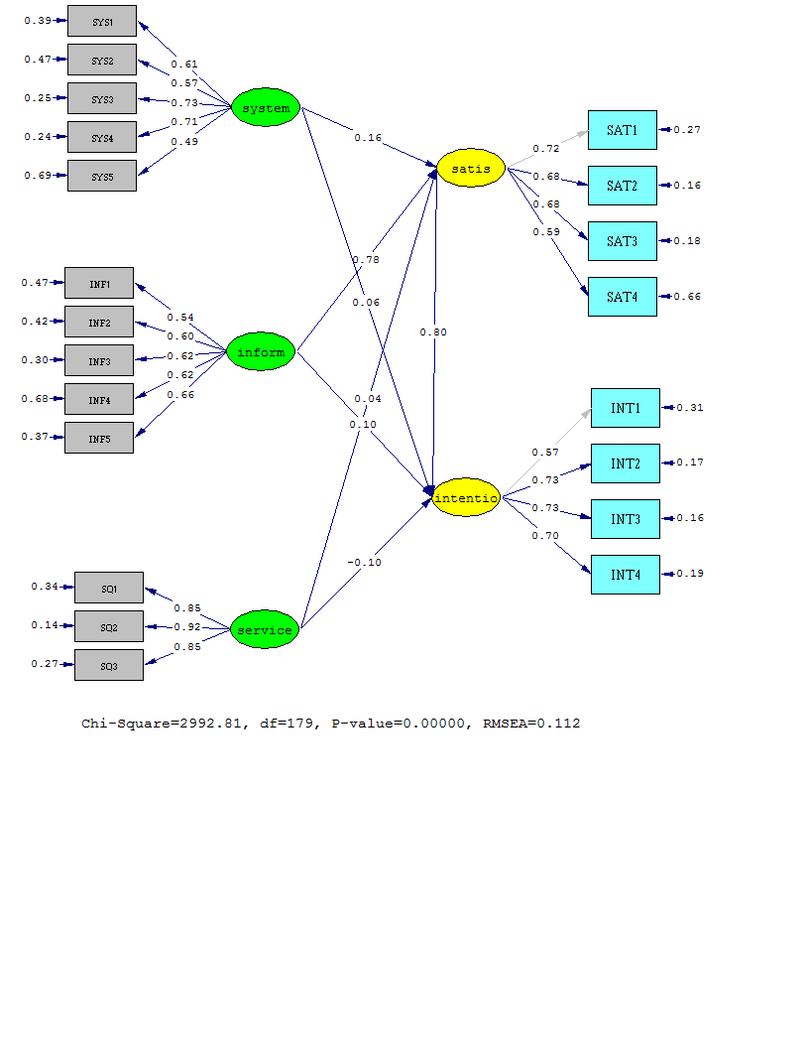

Measurement model has resulted estimation model (Figure 2) and t value model (Figure 3). Analysis the influence of each variables can be seen in the table 3. Based on that statistic result, it can be seen the summary of hyphotesis testing result on figure 4.

Figure 3: Model t-value | Tabel 3. Influences Between Variables
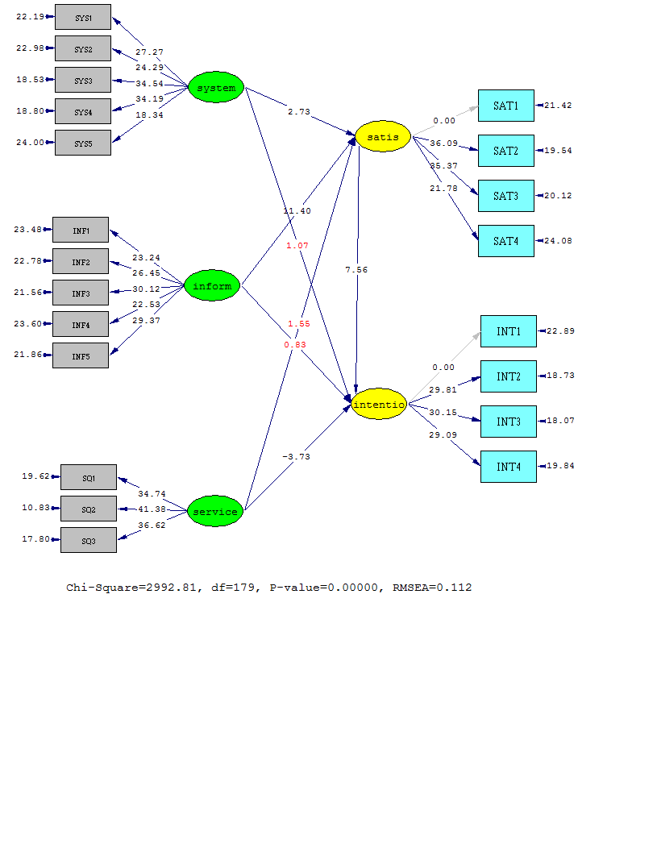 | Path Coeficient Koefisien Jalur R Square t t table Conclusion  System quality perceived satisfaction 0.16 2,56% 2.73 1,96 Significant  System quality intention to use 0.06 0,36% 1.07 1,96 Not Significant  Information quality perceived satisfaction 0.78 60,84% 11.40 1,96 Signifikan (Hipotesis diterima)  Information quality intention to use 0.10 1% 0.83 1,96 Not Significant  Service quality perceived satisfaction 0.04 0,16% 1.55 1,96 Not Significant  Service quality intention to use 0.20 4% 3.73 1,96 Significant  Perceived service intention to use 0.80 64% 7.56 1,96 Significant

Figure 4 : Hyphotesis Testing Results
SYSTEM
QUALITY
γ = 0.16
t =2,73

PERCEIVED SATISFACTION
γ = 0.06
t =0,36

γ = 0.78
t =11,4

β = 0,80
t = 7,56

INFORMATION
QUALITY
γ = 0.10
t =0,83

BEHAVIORAL
INTENTION
γ = 0.04
t =1,55

γ = 0.20
t = 3,73

SERVICE
QUALITY

Significant (α=5% :1,96)
Not Sig. (α=5% :1,96)
Concerning with the influence of service quality on perceived satisfaction and intention to use, the results showed that this study had not been able to prove that the service quality significantly influences the perceived satisfaction. Service quality that shows how the tutors provide feedback, respond and always provide solutions to the problems of the students has not been able to significantly affect the perceived satisfaction. This means that service quality cannot affect the satisfaction of oline tutorial participants in UT which was represented on the perceived benefit, namely helping students to understand the module, providing online learning experiences and providing responsive tutor supports at the time of interaction. This research can prove that service quality significantly influenced the intention to use online tutorials in UT. These findings indicated that the service quality that showed how the tutors provide feedback, respond and always provide solutions to the student’s problems affect the intention to use. This means that service quality impacted on a few things such as: the desire to reuse the online tutorials of UT, reluctance to recommend and encourage the other party (friends) using online tutorials. The findings of this study indicate that service quality encouraged behavior, that is the intention or desire to use online tutorials in the future. The research findings indicate that the tutor's readiness to respond and provide solutions to the problems of the students as online tutorial participants was assessed as something positive to encourage giving recommendation to other parties.
Concerning with the effect of system quality on perceived satisfaction and intention to use, this research can prove that the system quality may affect the perceived satisfaction, it means ease of students participating in online tutorials of UT in terms of the following: choosing the subjects to be studied, discussion, accessing anytime and anywhere as well as the use of simple, all of them overall can affect the satisfaction in utilizing online tutorials in UT. Student satisfaction as online tutorial user of UT was represented by the perceived benefit, namely helping to understand the module, providing online learning experiences and responsive supports of tutors at the time of interaction. Support of a reliable system quality on online tutorials of UT was indispensable for the role of a reliable IT infrastructure is important, because it is responsive internet design, where technology is the basis of instructional design for changing the online tutorials to be adaptive behavioral learning. However, this study did not manage to prove that the quality sytem significantly affect on intention use. These findings indicated the ease of students as online tutorials participants of UT in choosing the subjects to be studied, discussion, accessing anytime and anywhere, and simple usage overall did not have a significant impact on the intention to use. This means that the system quality was assesed by students participating in online tutorials of UT not able to provide a significant impact on a few things such as: the desire to reuse the Tuton UT, reluctance to recommend and encourage the other party (friends) using online tutorials and do not want to spread positive things about online tutorials on to others. This study result indicates that system quality is not enough to affect the intention to use the online tutorials. This finding may indicate that the quality system which is strongly influenced by the quality of the technology does not play an important role in supporting the functional aspect of e-learning, to which according to Cheng (2012) shows the flexibility, convenience and reliability that can impact the quality of online tutorials that ultimately has not been able to make the students participating in online tutorials to recommend and communicate positive things to others (friends, family).
Concerning with the influence of information quality on perceived satisfaction and intention to use, the study can prove that the information quality significantly influences the perceived satisfaction. This means that the quality of information on online tutorials of UT, namely in terms of substance, the presentation of the material, aspects of interest in the process of online learning, ease of discussion and the structured structured, overall affects on perceived satisfaction. The students’ satisfaction as online tutorial users in UT is represented on the perceived benefit, namely in helping to understand the module, providing online learning experiences and responsive tutor support at the time of interaction. However, this study did not manage to prove that the information quality significantly influences the intention to use. These findings indicated that the quality of information on online tutorials of UT in terms of substance, material presentation, aspects of interest in the process of online learning, ease of discussion and structured schedule, overall affects the perceived satisfaction and did not have a significant impact on the intention to use. That means information quality assessed by students as participants of online tutorials of UT cannot provide significant impact on a few things such as: the desire to reuse the Tuton UT, reluctance to recommend and encourage the other party (friends) to use online tutorials and do not want to spread the positive things about online tutorials to others.
Concerning with the impact of perceived satisfaction, this research was succesfully proved that the perceived satisfaction has powerful influence on the intention to use. This means that the perceived satisfaction of students as participants of online tutorials of UT is represented on the perceived benefit of helping to understand the module, providing online learning experiences and responsive support from tutors at the time of interaction, the overall impact on intention to use. The intention to use in this study is indicated as a desire to reuse online tutorials of UT, reluctance to recommend and encouraging other party (friends) using online tutorials. This study supports the concept/theory and empirical studies conducted by several experts such as a study of Cheng (2012 ) which shows that the quality (information, systems and services) is an important determinant that may affect the acceptance of e-learning. Then, Ho (2009) suggests that the determinants of e-learning outcomes are the quality system, technology readiness and learning behavior. Learning outcomes in this case are related to skill development and satisfaction. Ma et al (2013) defines behavioral intention as an intention to continue using e-learning which is affected by factors of ease of use, quality of information and benefits. Similar opinion is stated by Chen et al (2011: 1596), that "intention of use of e-learning is influenced by the benefit of innovative technology and affect satisfaction ".
Conclusion and Future Research
The findings of this study modeling may prove three hypotheses that had positive and significant effects, which is perceived satisfaction which was influenced by system quality and information quality, intention to use which was significantly affected by service quality and perceived satisfaction. However, other hypotheses proved that system quality and information quality did have significant effect on intention to use, and service quality did not significantly influence theperceived satisfaction. Facts on the ground indicate that the online tutorial services to students had not been optimized. If futher explored, it was known that mostly students considered the user interface on the quality system included as medium category, whereas in information quality, especially the ease of discussion and presentation of the material were assessed as not optimal by the students. Overall, service quality was assessed as not optimal by students as online tutorial participants and was categorized as medium. These findings indicated that the tutor function as a facilitator and course manager is not optimal yet meaning has not been actively providing feedback, responses and solutions to the problems of students. Service quality that is not optimal yet becomes the cause of insignificant effect on the intention to use, namely in notifying the positive things about online tutorials.
Based on these findings, research needs to be done to measure important determinant factors affecting satisfaction and intention to use related to system quality and information quality.

References
Ajzen dan Fishbein, M. 1975. Belief, Attitudes, Intention and Behavior: An Introduction to Theory and Research. Addison-Wesley, Reading, MA.
Ajzen, I. dan Fishbein, M.1980. Understanding Attitudes and Predicting Social Behavior, Prentice-Hall, Englewood Cliffs, NJ.
Ajzen, Icek.1991. The Theory Of Planned Behavior, Organizational Behavior And Human Decision Process, Vol 50, Pp. 179-211.
Al-Adwan, Ahmad, A and Jp. Smedley. 2013. Exploring students acceptance of e-learning using Technology Acceptance Model in Jordanian Universities.
Boston Consulting Group. 2001. “Winning the online consumer 2.0: converting traffic into profitable relationship”, available at: www.bcg.com
Budiwati, Y. 2007. Influences of online Tutorial Management on Sudent’s participation. Journal of Open and Distance Education, 8 (1), 57
Chen , Man L et al. 2011. Influence of Dentistry Student’s e-learning System Satisfaction: A Questionnaire. J. Med Syst. 35, 1595-1603.
Chen, C.W. 2010.Impact Quality Antecedents on Taxpayer Satisfaction with Online Tax-filling systems.An empirical Stduy Information and Management, 47 (5-6).308-315.
Cheng, Y Ming. 2012. Effects of quality antecedents on e-learning acceptance. Internet Research Vol. 22, No. 3. Pp 361-390.
Cheng, Yung Ming. 2012. Effects of Quality Antecedents on E-learning Acceptance. Internet Research.Vol.22, No.3 pp 361-390.
Chiu, Chao Min et al. 2005. Usability, Quality, Value and E-learning Continuance Decisions.Computers & Education 45. Science Direct, 399-416.
Cooper, Donald. R.; P.S. Schindler. 2011. Business Research Methods. Asia: Mc Graw-Hill International edition, 11 edition.
Cristobal, E., Flavian, C. And Guinaliu, M. 2007. “Perceived e-service quality (PeSQ): measurement validation and effects on consumer satisfaction and web site loyalty”, Managing Service Quality Vol.17 No.3, pp 317-40.
Daulay, P. dan Zaman, B. 2012. “Pengembangan Model Penelusuran Diskusi Tutorial Online Melalui Aplikasi FAQ (Frequently Ask Question)”, Jurnal Pendidikan Terbuka dan Jarak Jauh, Vol. 13, No. 2, pp. 80 – 93.
Davis, F.D. 1989. Perceived usefulness, perceived ease of use, and user acceptance of information technology, MIS Quarterly, Vol. 13 No. 3, pp. 319-39.
Davis, F.D. dan Venkatesh, V. (1991), "A critical assessment of potential measurement biases in the technology acceptance model: three experiments", Human-Computer Studies, Vol. 45, pp. 1945.
Delone and Mc Lean. 1992. Information System Success: The Quest for Dependent Variable. Infornation System Research. (3:1). Pp 60-95.
Dewatisari, W.F; Suprijanto and Sugiyanto. 2010. Obstacle of Online Tutorial Use By Students of Non-Basic Education in UT’s Regional Office-Bandar Lampung. Universitas Terbuka.
Fatia F., Andriyansah, Purqaningdyah MW, 2012. Analyses of the Use of Online Tutorial. US-China Education, A7, 670-675
Fendini Duan Ayu., Kertahadi dan Riyadi. Pengaruh Kualitas Sistem dan Kualitas Informasi terhadap kepuasan Pengguna AP2T.PLN Persero Malang.
Gounaris,S and Dimitriadis, S. 2008. Assesing Service Quality on the Web.Journals of Services Marketing, Vol.17.No.5
Hair,J.F; G. Tomas M; C. M. Ringle; M. Sarstedt. 2013. A Primer on Partial Least Squares Structural Equation Modelling (PLS-PM). Sage Publication, Inc-Los Angeles.Pg.11-28.
Ho, Li An. 2009. The Antecedents of E-learning Outcome: An Examination of System Quality, Technology Readiness, and Learning Behavior. Adolesscence, Vol. 44, No.175.
Islam, A.K.M Najmul. 2010. The Determinant of The Post Adoption Satisfaction of Educators with E-learning System. Journal of Information System Education, Vol 22(4)
Jeh, Her.wu; Robert D.T and Tzyh LH. 2010. A study of student satisfaction in a blended e-learning system environment. Journal Computers and Education, Vo. 55, Issue 1, pp 155-164.
Jogiyanto, HM. 2005.Analisis dan Desain Sistem Informasi: pendekatan terstruktur, teori dan aplikasi bisnis, Ed.3. Yogyakarta.
Julaeha, Siti. 2005. The Application of E-Learning in Tutorial Process. Indonesia.
Kotler, Philip, Dan KL. Keller, 2010. Marketing Management, Person International, Prentice Hall- New Jersey, 15Edition.
Lee, S., Shin, B., and Lee H.G. 2009.Understanding Post-adoption Usage of Mobile Data Services: The Role of Supplier Side Variables.Journal of the Association for Information System, Vol.10, No. 12. Pp 860-888.
Liaw, Shu Sheng. 2007. Investigating Student’s Perceived Satisfaction, Behavioral Intetnion, and Effectiveness of e-learning: A Case Study of The Blackboard System. Computer and Education 51, 864-873.
Livari, J. 2005. An Empirical Test pf the Delone and Mc Lean Model of Information System Success. Data base for Anvances in Information Syatems. Bol. 36, No, 2 P. 8
Ma, Chih Min. et al. 2013. Integrating Technology Acceptance Model and Task Technology Fit Into Blended e-learning System. Journal of Applied Science 13 95) 736-742.
O’Brien James A. 2005.Introduction to Information System, 12 the Edition. Mc Graw.
Parasuraman, A., V.A. Zeithaml & L.L. Berry, 2000, SERVQUAL : A Multiple Item Scale for Measuring Customer Perceptions of service Quality, Journal of Retailing, Vol. 64.
Rai A., Lang ,S.S and Welker, R,B. 2002. Assessing the Validity of IS Success Models: An Emperical Test and Theoritical Analysis. Information System Research.Vol. 13, No.1. pp:29-34
Roca, J.C ; Chiu,C.M. and Martinez F.J. 2006. Understanding e-learning continuance intention: an extension of the Technology Acceptance Model”, International Journal of Human Computer Studies, Vol. 64, pp.683-99
Saleh, Taufik; Darwanis dan Usman Bakar. 2012. Pengaruh Kualitas Sistem Informasi Terhadap Kualitas Informasi Akuntansi Dalam Upaya Meningkatkan Kepuasan Pengguna Software Akuntansi pada Pemda Aceh. Jurnal Akuntansi Pasca Sarjana Universitas Syah Kuala, Vol. 1, No. 1.
Seddon. 1997. A Respefication and Extension of the Delone and Mc Lean Model of IS Success. Information System Research.Vol. 8, No.3. pp:240-253
Soomers, T.M. Nelson, K and karimi,J. 2003. Confirmatory Factor Analysisi of the End User Computing Satisfaction Instrument: Replication Within an ERP Domain. Decision Sciences, 34 (3) 595-62.
Taylor, s and Todd,. 1995. Decomposition and Crossover Effects in The Theory of Planned Behavior: A Study of consumer adoption intentions. International Journal of Research in Marketing, Vol. 2.pp 137
Ventakesh,v and F.D Davis. 2000. A Theoritical Extension of the Technology Accetance Model: Four Longitudinal Field Studies. Management and Science, Vol 46, No. 2 Feb, pp 186-204
Vinzi V.E, et.al. 2010. Handbook of Partial Least Squares.Concepts, Methods, and Applications. Springer

Zeithalm Valarie A. Marry Jo Bitner, 2000, Services Marketing: Integrating Customer Focus Across The Firm, Irwin Mc Graw Hill.

